**Web Goat Report 2019**

**Module: Computer Security**

**Name: Mark Carley**

**Student Number: 20071864**

**Course: Creative Computing**

**Contents**

1. Installation of all software packages and OS………………………………………….3
2. SQL Injection (Normal)………………………………………………………………………….4
3. Missing function Level Access Control…………………………………………………..5
4. SQL Injection (Advanced)………………………………………………………………………7
5. HTTP Basics…………………………………………………………………………………………..9
6. HTTP Proxies…………………………………………………………………………………………9
7. Authentication Bypasses……………………………………………………………………….11
8. Client Side Filtering……………………………………………………………………………….12
9. Insecure Login……………………………………………………………………………………….14
10. HTML Tampering…………………………………………………………………………………..15
11. Learning Outcomes from tasks……………………………………………………………..16

**Installation of all software packages and OS**

The operating system I’ve been using for this assignment is windows and browser being Firefox. The main application being used here is “**Web-Goat**” which is a deliberately insecure web application that is maintained by “**OWASP**”. The software is built on top of Java and is best used for practicing web security concepts.

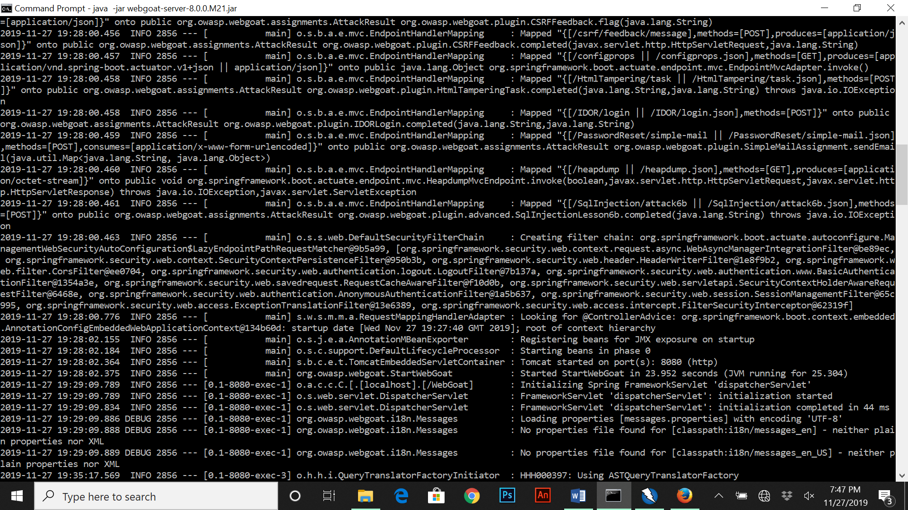When installing “Web-Goat” on my own machine I had to update and install both the Java SDK version up to 11.0.5 and the base version of Java to it’s newest version as well, if not the program doesn’t compile. The version of “Web-Goat” I installed was from the following link (<https://github.com/WebGoat/WebGoat/releases/tag/v8.0.0.M21>). Once I downloaded the “Web-Goat” jar file I had to open the command prompt and find the directory for the file. When the directory was put into CMD, I ran the following code (java –jar webgoat-server-8.0.0. M21.jar).

The next piece of software to download was “**ZAP**” which is a open-source web application security scanner. It’s primarily used by web developers or security experts during penetration tests to access web applications for vulnerabilities. The site I downloaded from is available from the link (<https://www.owasp.org/index.php/OWASP_Zed_Attack_Proxy_Project>). Zap installs like a normal application so it’s not too difficult.

One of the final tasks to do was to configure Firefox to allow ZAP to proxy, when doing this on Firefox I went into settings, network settings and changed the manual proxy configuration to 8084. From there I just restarted Firefox, next I did the same process for ZAP which was in options, local proxies and changed the port to 8084. Once that was all finished I rebooted both Web Goat and ZAP and the two pieces of software was connected and searched (

).

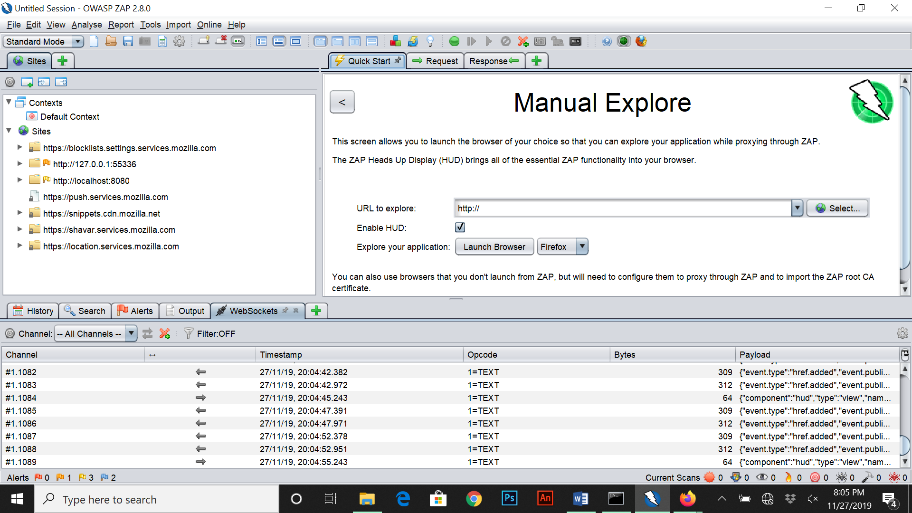One problem that was ran into was when the port numbers were changed the browser wouldn’t connect, so the solution was to use the manual explore under quick start on ZAP which seemed to work.

**SQL Injection (Normal)**

The purpose of this lesson is to peform tasks to manipulate SQL (Structured Query Language). The two main tasks in learning here is both String SQL injection and Numeric SQL Injection. An SQL Injection attack consists of insertion of malicious data via SQL query input from the client of an application. Successful SQL injection exploits can:

* Read + Modify sensitive data from database.
* Execute administrative operations from database.
* Recover content of a given file present on the DBMS file system.
* Issue commands to the operating system.

Below is an example of both a potential String injection and Numeric Injection:

"select * from users where name = '" + userName + "'"; **(String)**

"select * from users where employee_id = " + userID; **(Numeric)**

Attackers can supply unexpected text such as:

* userName = Smith' or '1'='1
* userName =' or 1=1 –
* userID = 1234567 or 1=1
* UserName = SmithÃ¢â‚¬â„¢;drop table users; truncate audit_log;--

For the first exercise it wants us to extract users from the users tables using String SQL Injection.

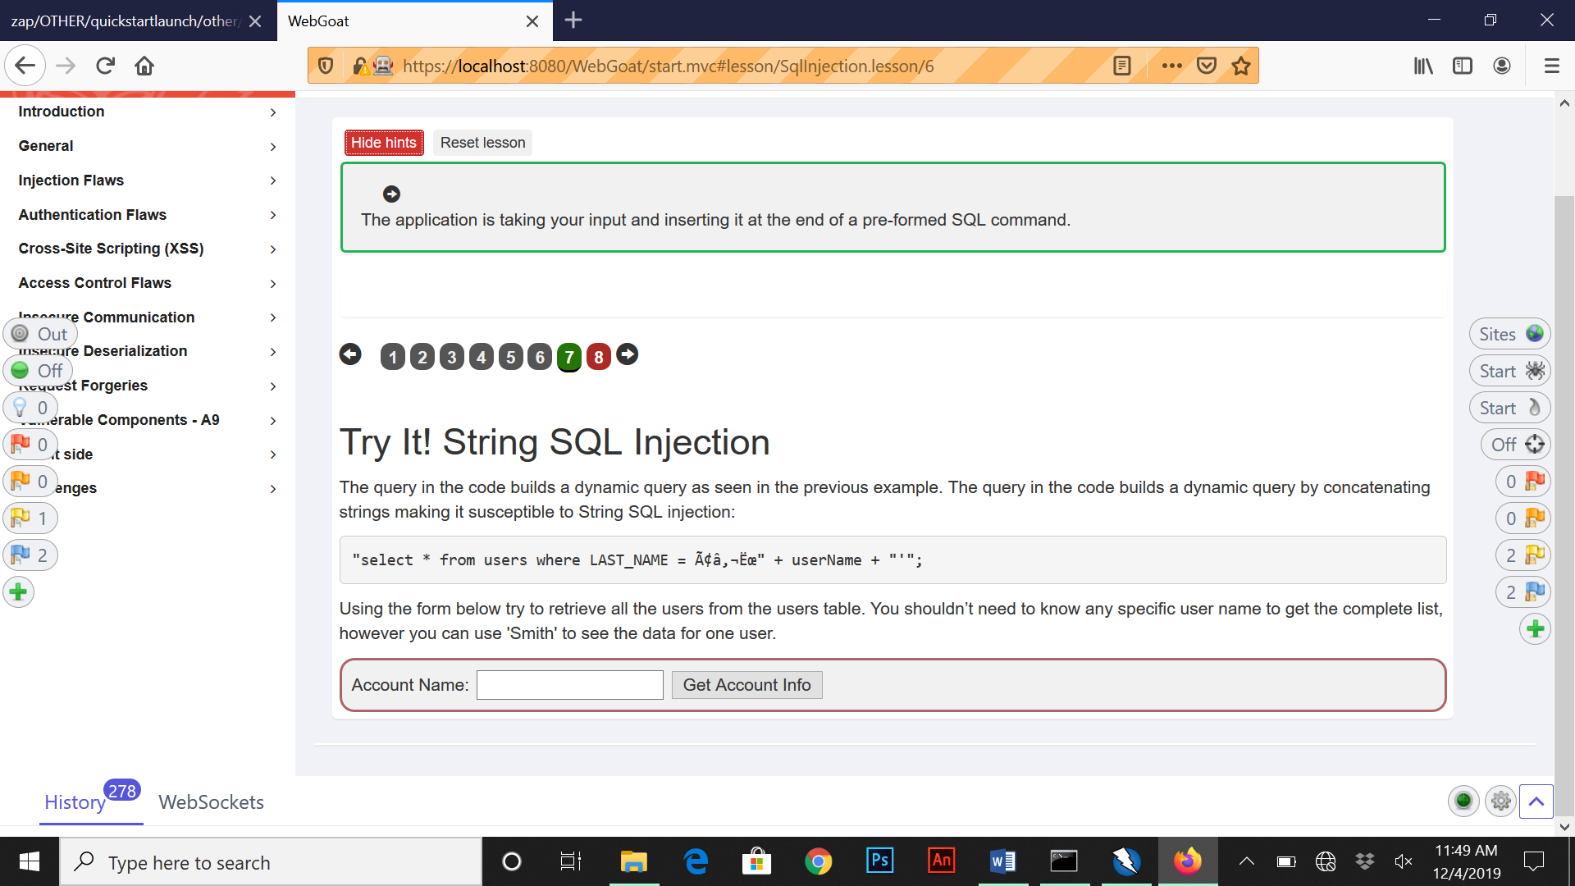

Once we enter the following line “smith’ OR ‘1’ =’1” onto account name were are given back data for the user below:

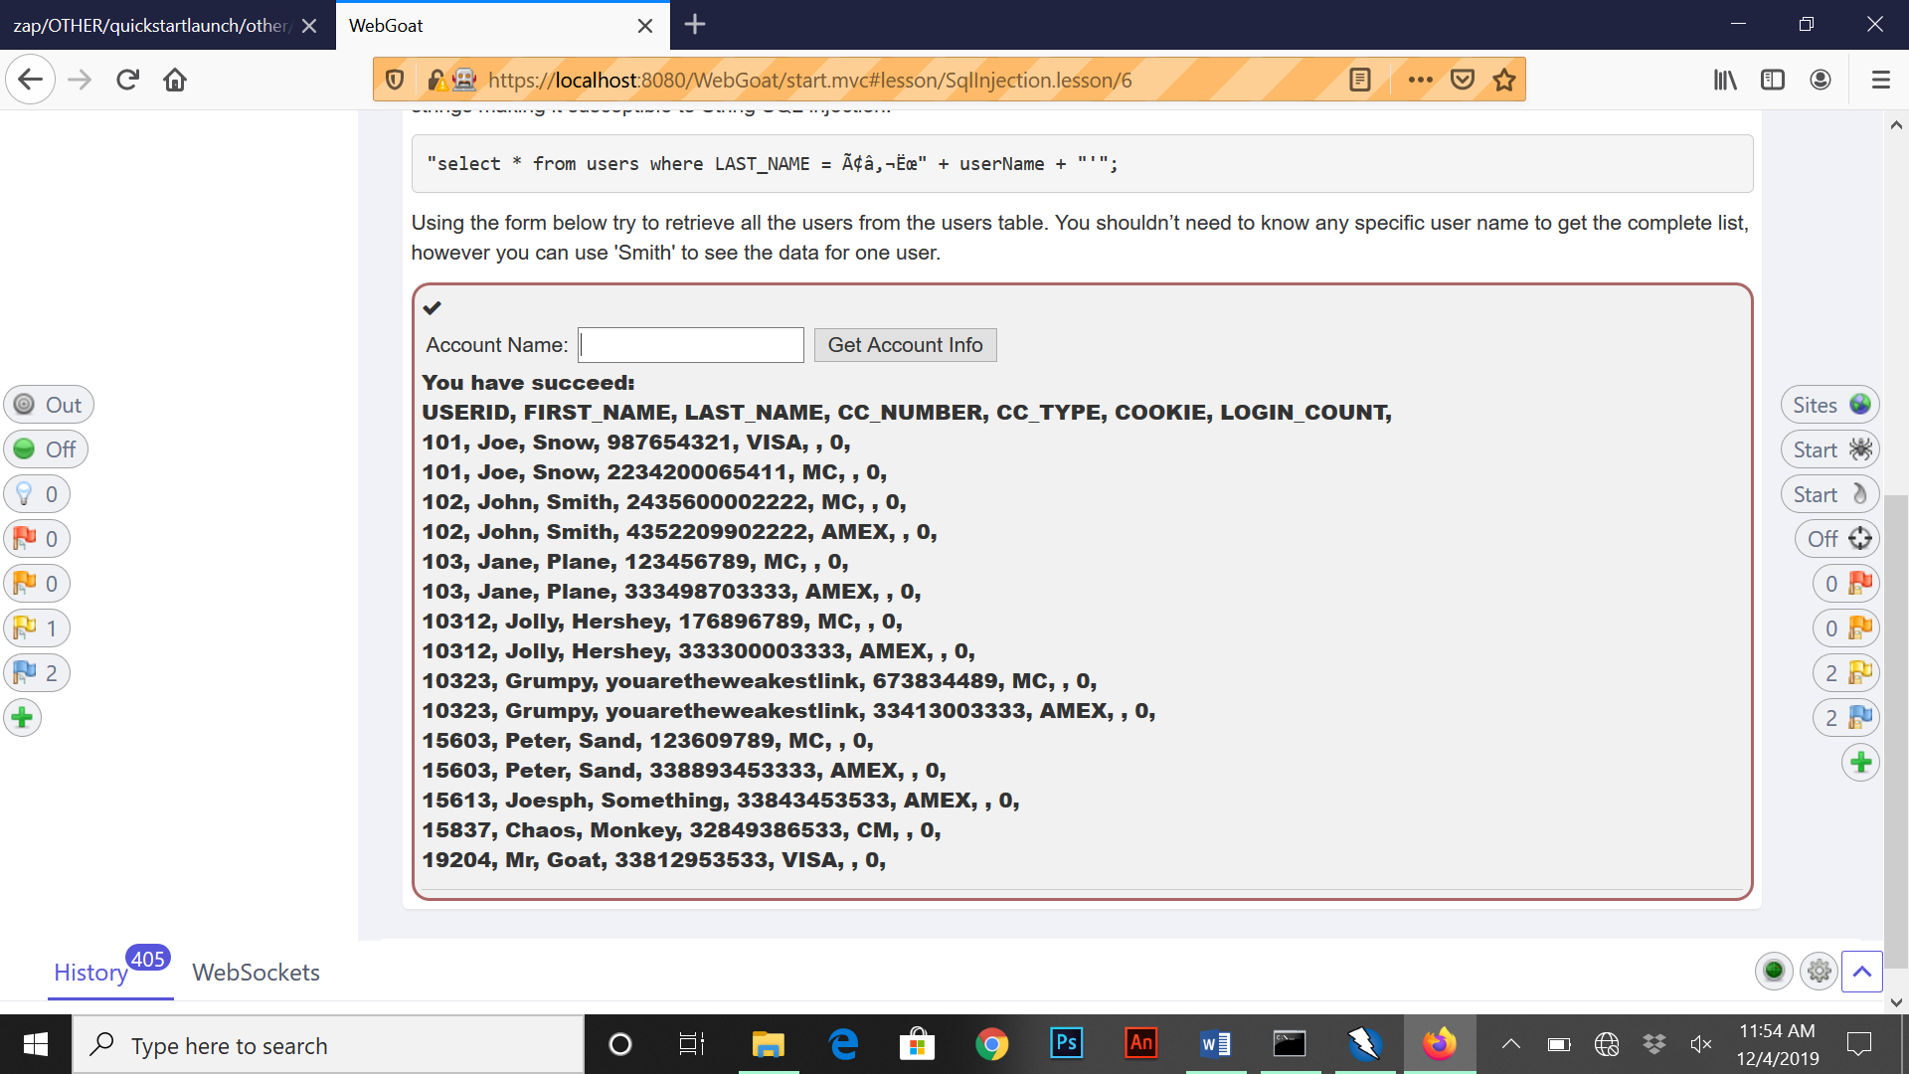

For the last exercise of this section we are given a form to retreive all users data so we enter “101” to retreive specific user data.

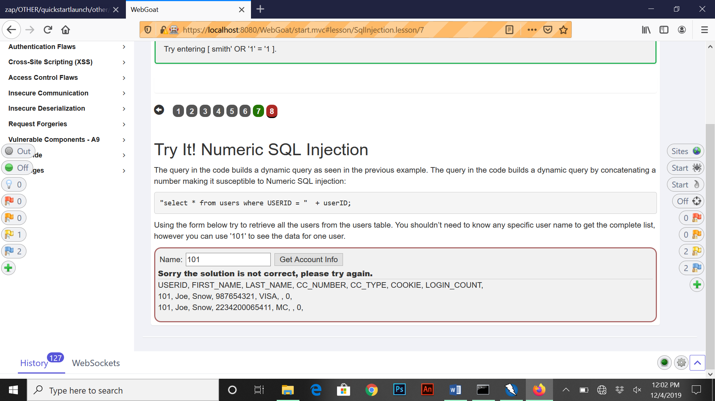

**Missing Function Level Access Control**

For this exercise we are tasked with finding two items that don’t appear visible on the menu interface for the first part of the question. For this we inspect elements by right clicking over the log out function on the menu and looking for hidden elements not seen on screen.

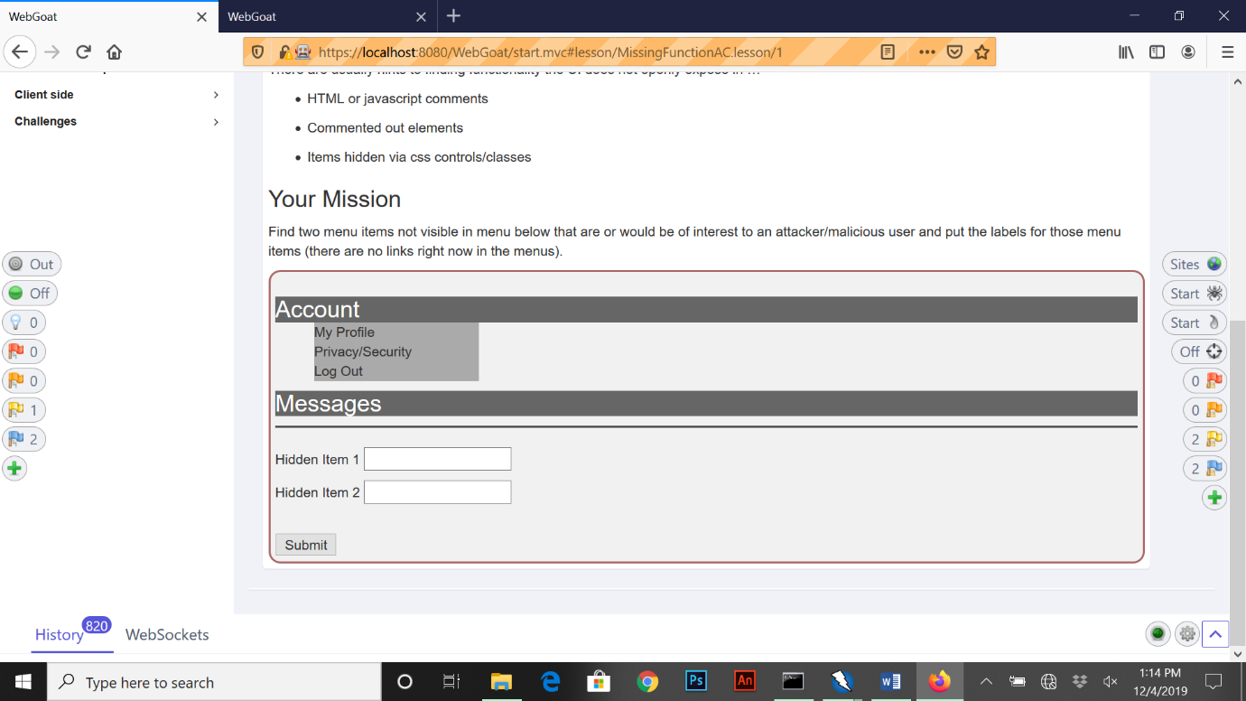

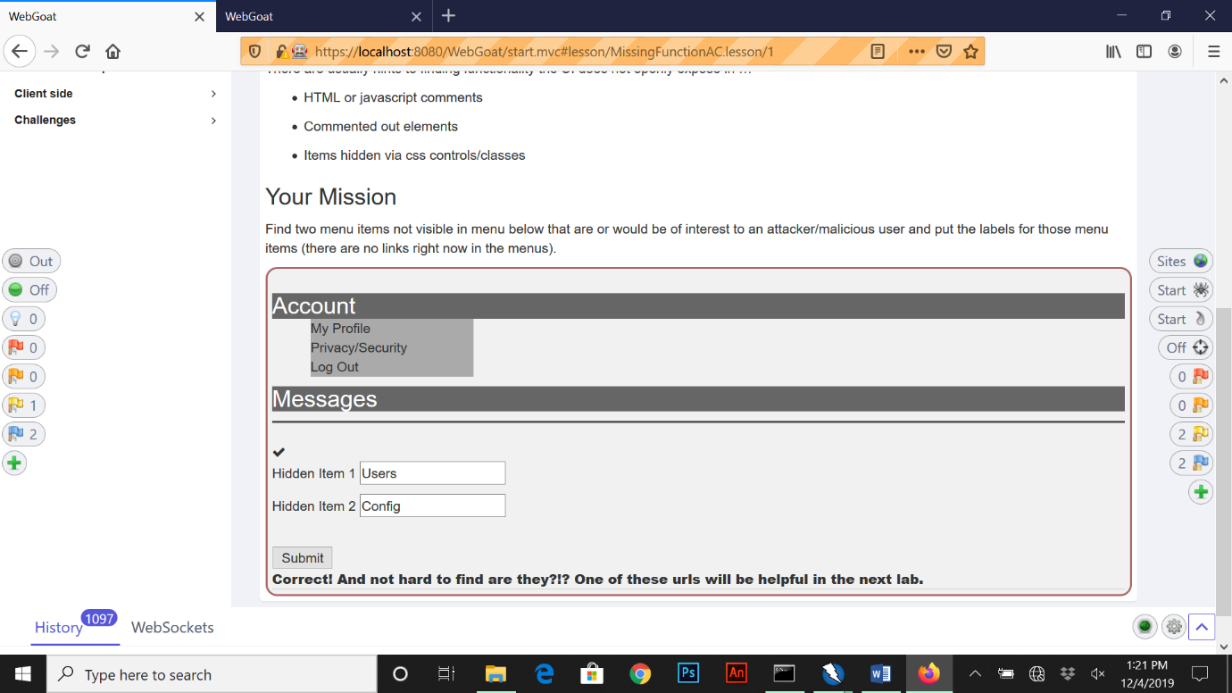When we right click, inspect element under log out, we find two values called “Users” and “Config” under the div ID “ui-accordion-ac-menu-panel-2”. From here we input the answers I found and move on to the next section.

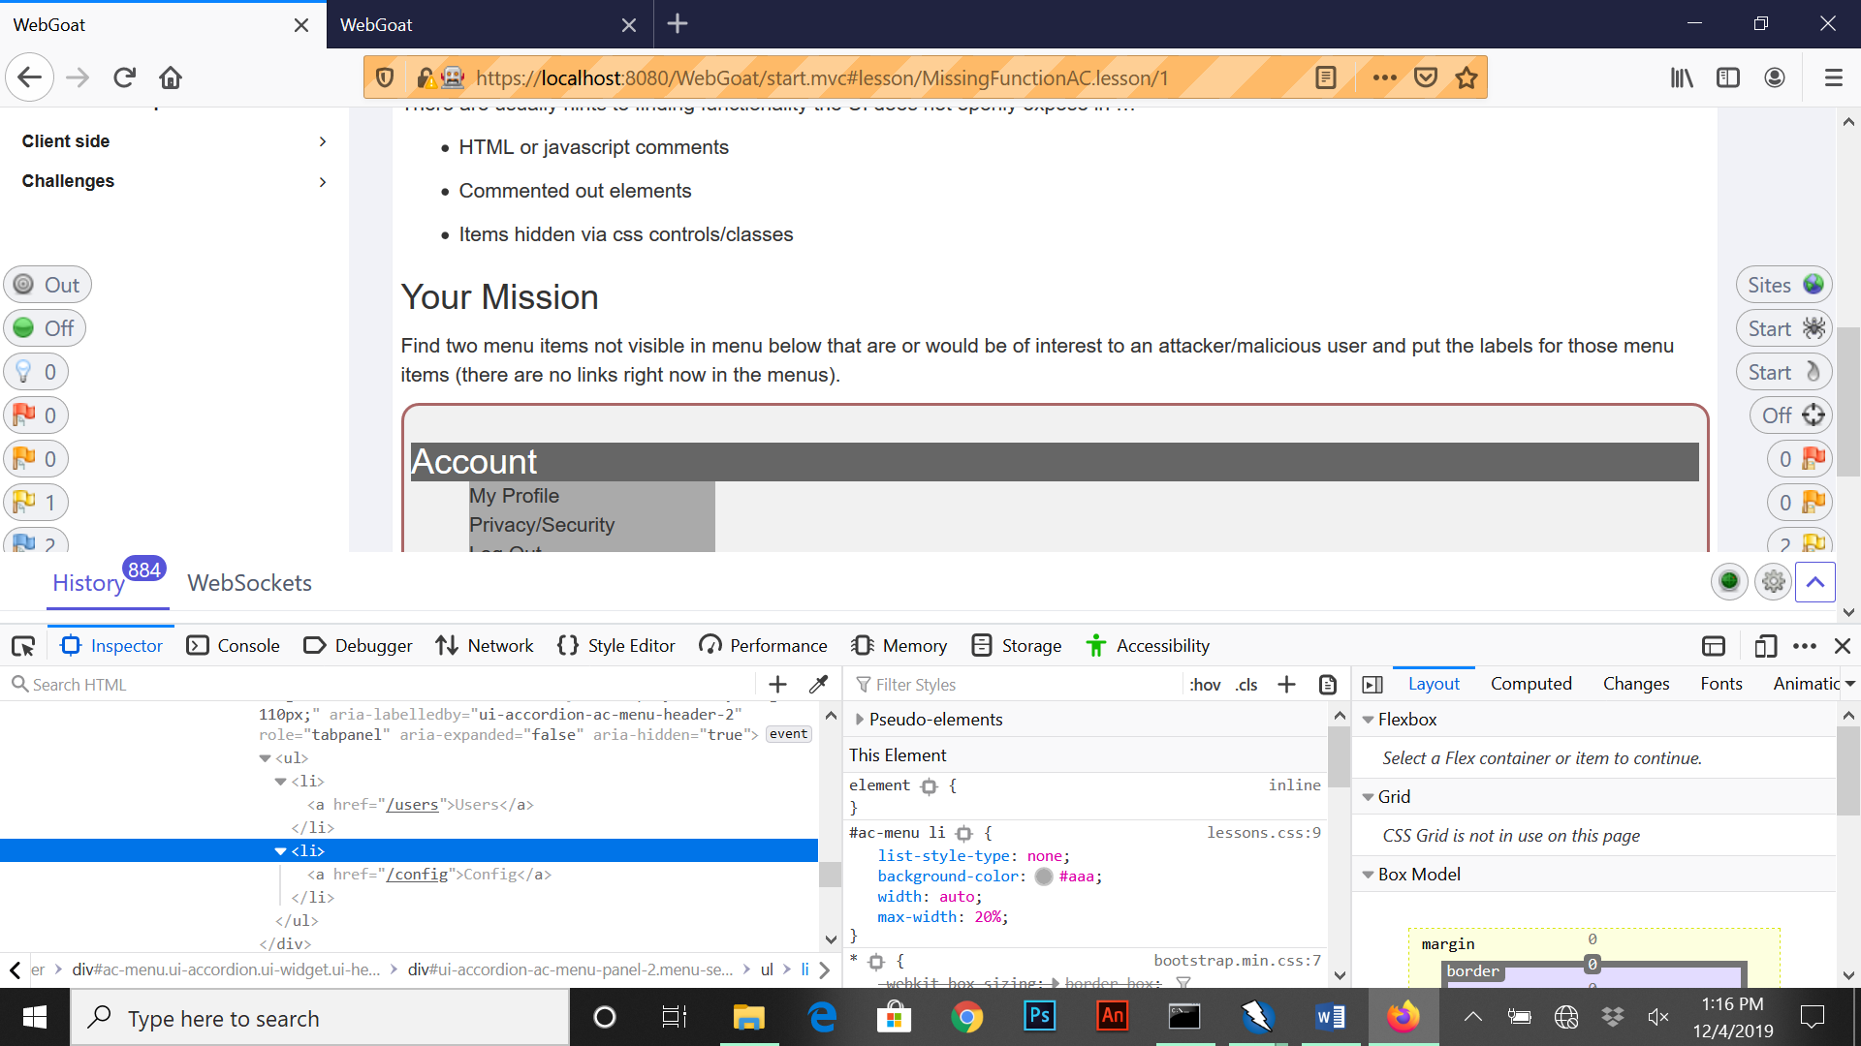

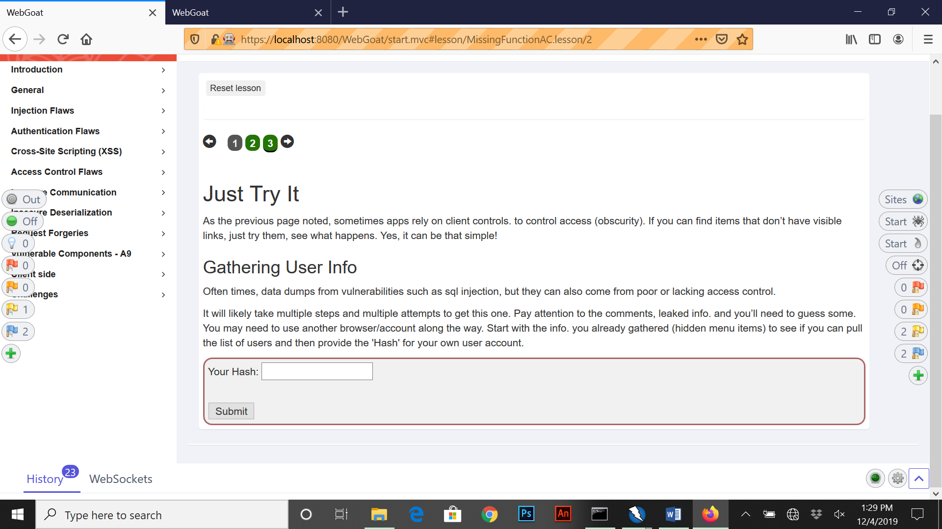For the last part of this section, this will require gathering user info from data dumps. The purpose of this exercise is to point of flaws from poor or lacking access control via web applications. For this section we are required to gather a user hash when trying to gather information from incoming/outgoing responses from the web application.

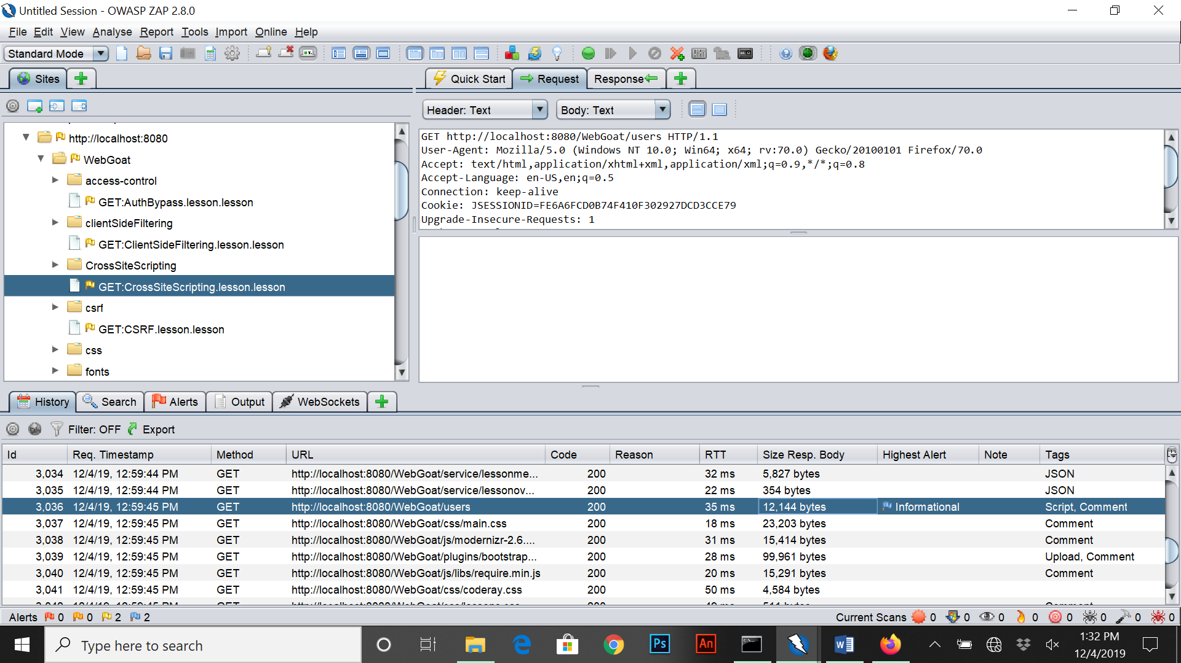To start I copied the URL of localhost and made the following adjustment <https://localhost:8080/WebGoat/users>. From here I went over to Zap and looked for the script/comment tag requested out for Web Goat users.

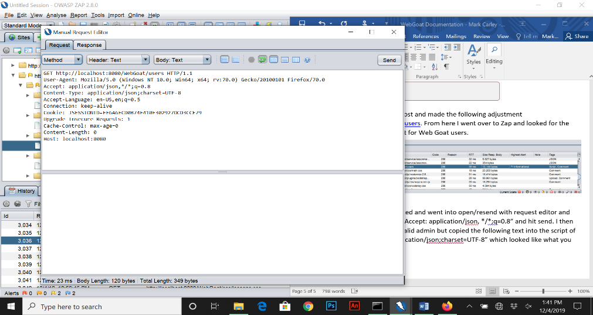Once I found the script I right clicked and went into open/resend with request editor and made the following adjustments “Accept: application/json, */*;q=0.8” and hit send. I then received a response back with invalid admin but copied the following text into the script of what I found “Content-Type: application/json;charset=UTF-8” which looked like what you see below:

Once I edited and copied the information in I hit resend and gave back username, admin (false) and a user hash value that we need.

The following Hash we get is “uxOdW8Z8MqJlzdpvc47syI/f+OwnJLsCl6BahPOXJ/U=” which is the resolution we need.

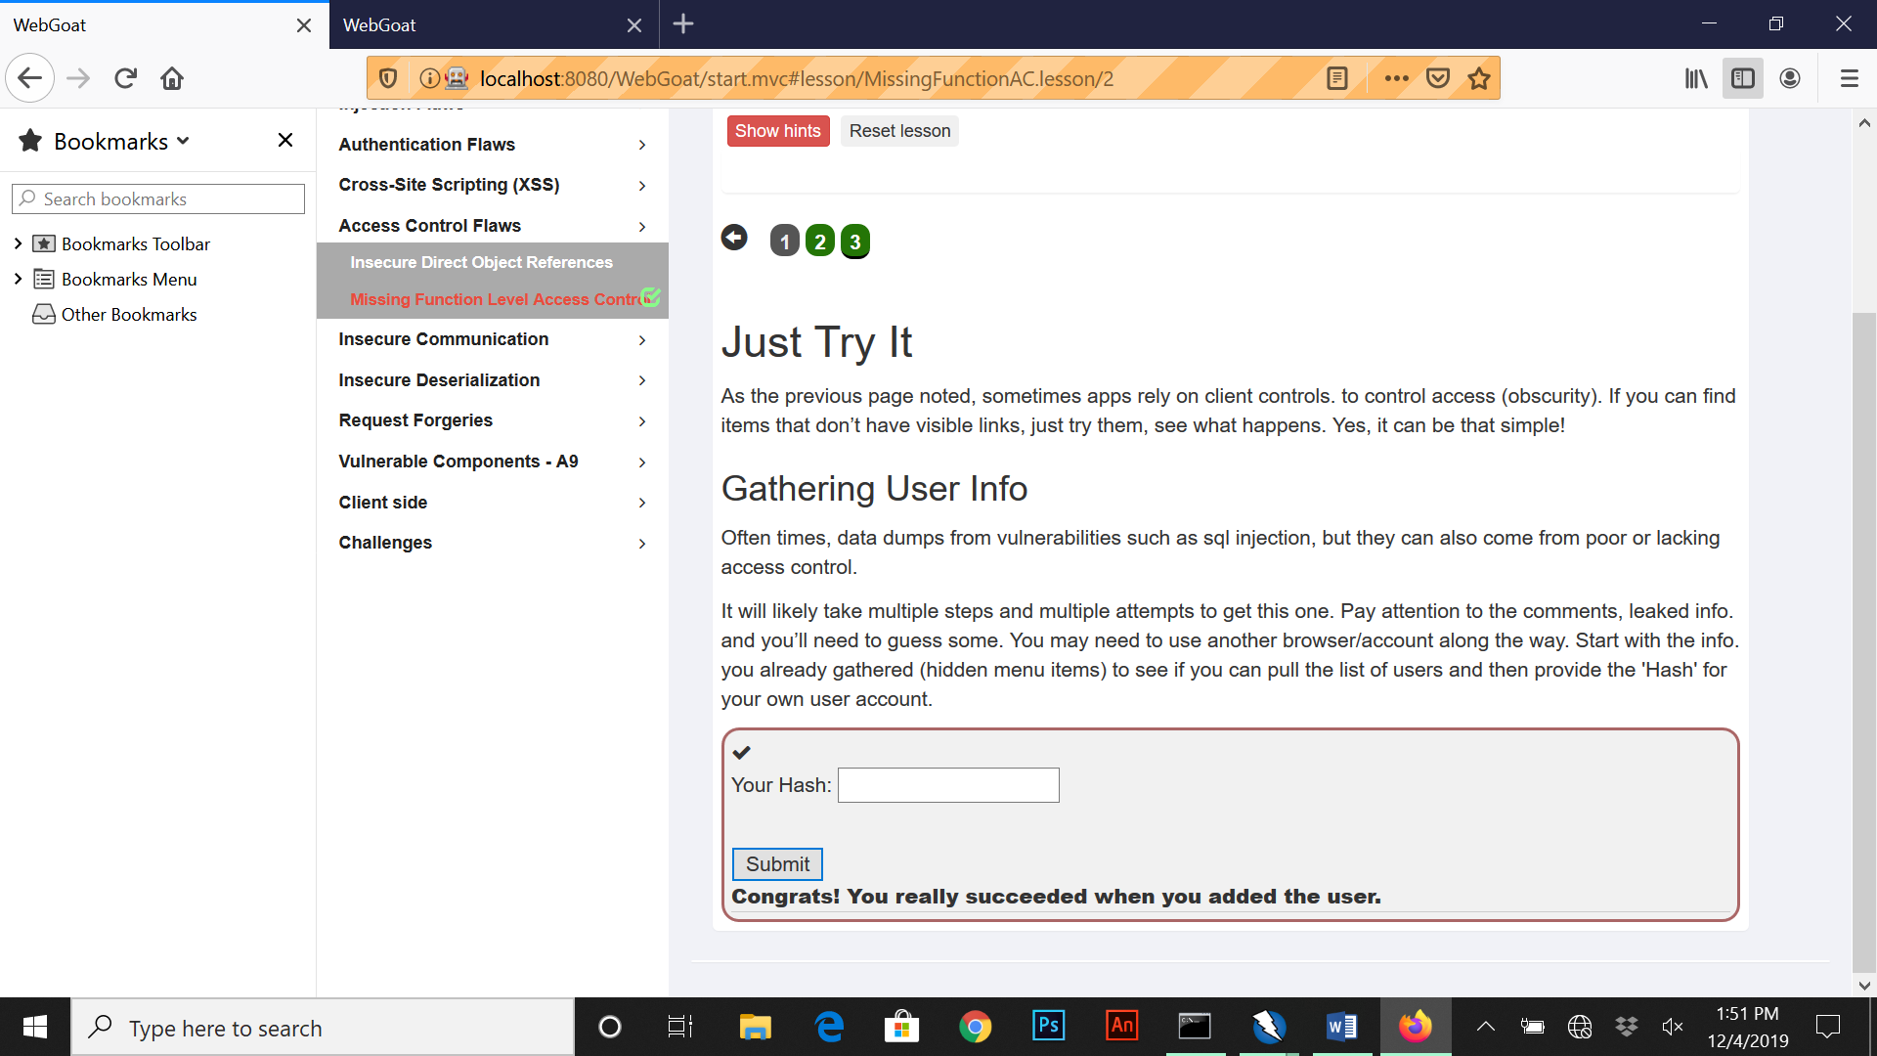

**SQL Injection (Advanced)**

This lesson covers more complex topics of SQL Injection such as combining SQL Injection techniques and Blind SQL Injection. This lesson also covers the basis of special statements using Unions ('Select id, text from news union all select name, pass from users') and Joins which allow connecting to other tables.

For the first question we are asked to execute a query to union or join tables together then once the information is received we asked to get “Dave’s” password for the second part of the question.

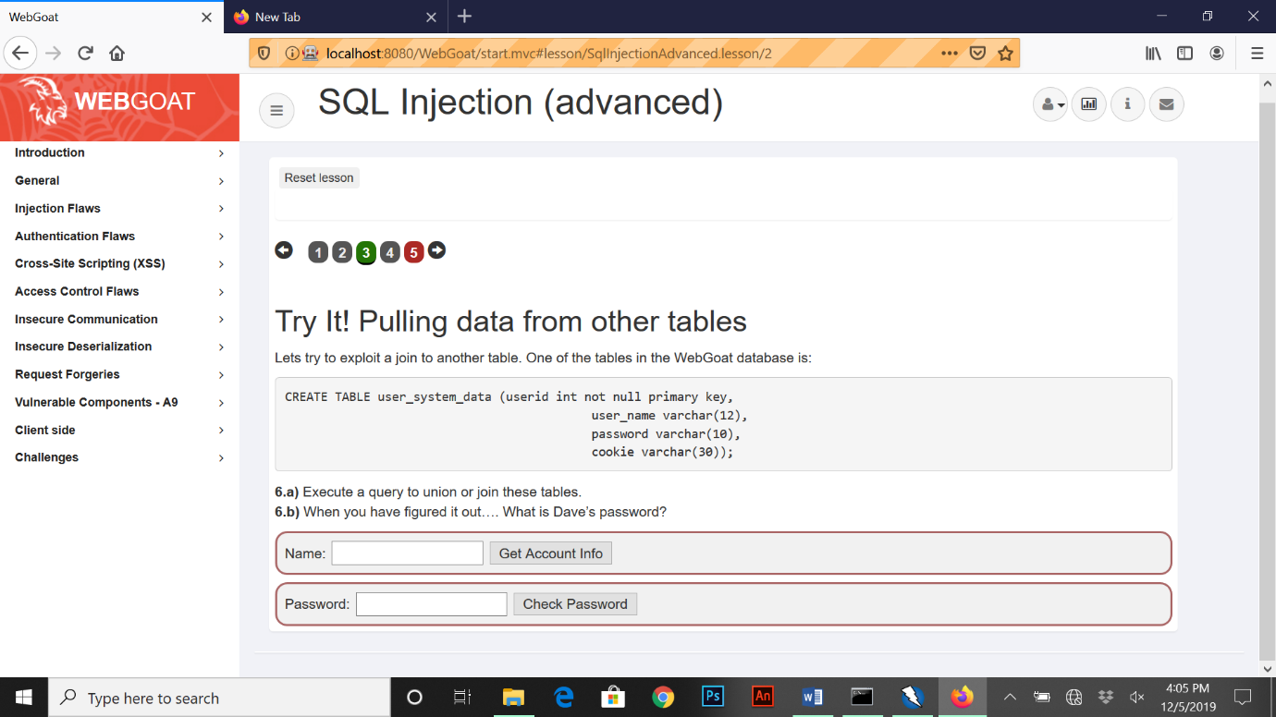

To fetch account info I’ve executed the following code “ ' or 1=1 union select userid,user_name,password,null,null,null,0 from user_system_data—“.

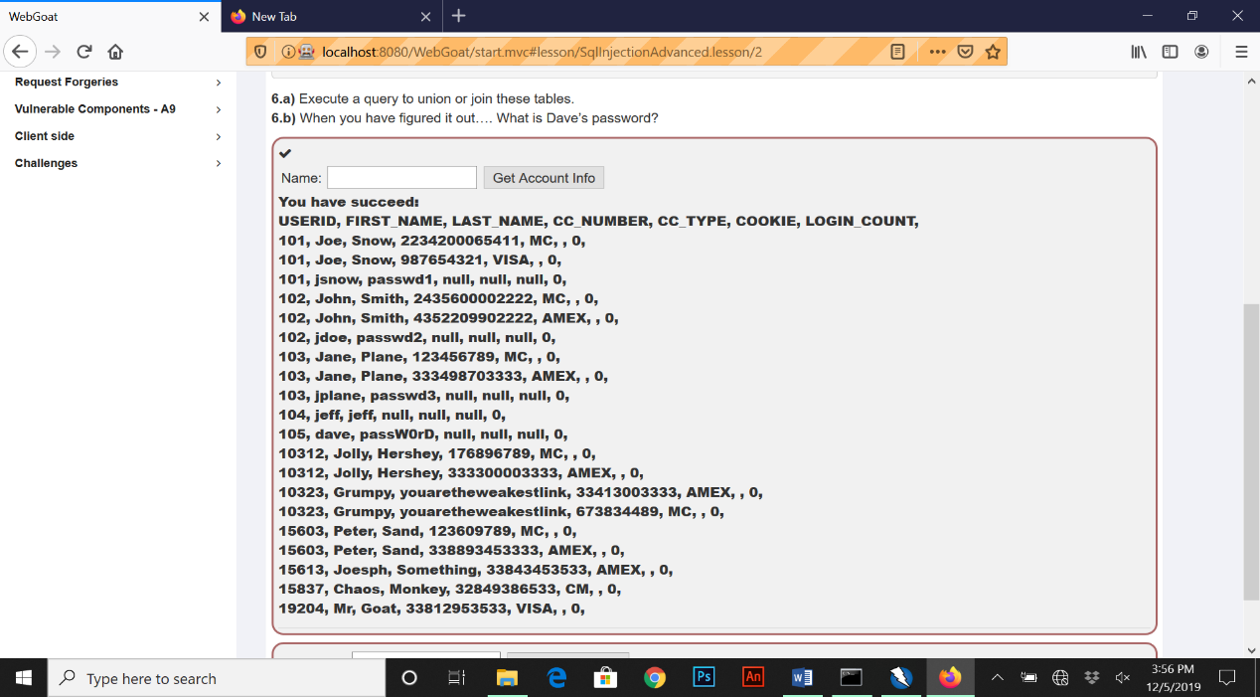

Here we can see the listing of the user “dave” and password information.

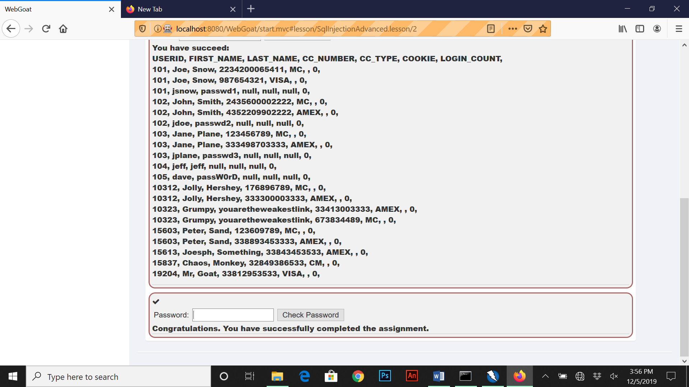

For the next section of this topic we are asked to incorporate blind SQL injection to try and receive login information. We are given a user log in and registration form in which we have to guess the password for “tom”.

The first thing I did was create a method when registering as tom to see the current number of characters for the password using the following line “tom’ and length(password) >10 –“ but was able to narrow it down to 23 characters “tom’ and length(password) = 23—“.

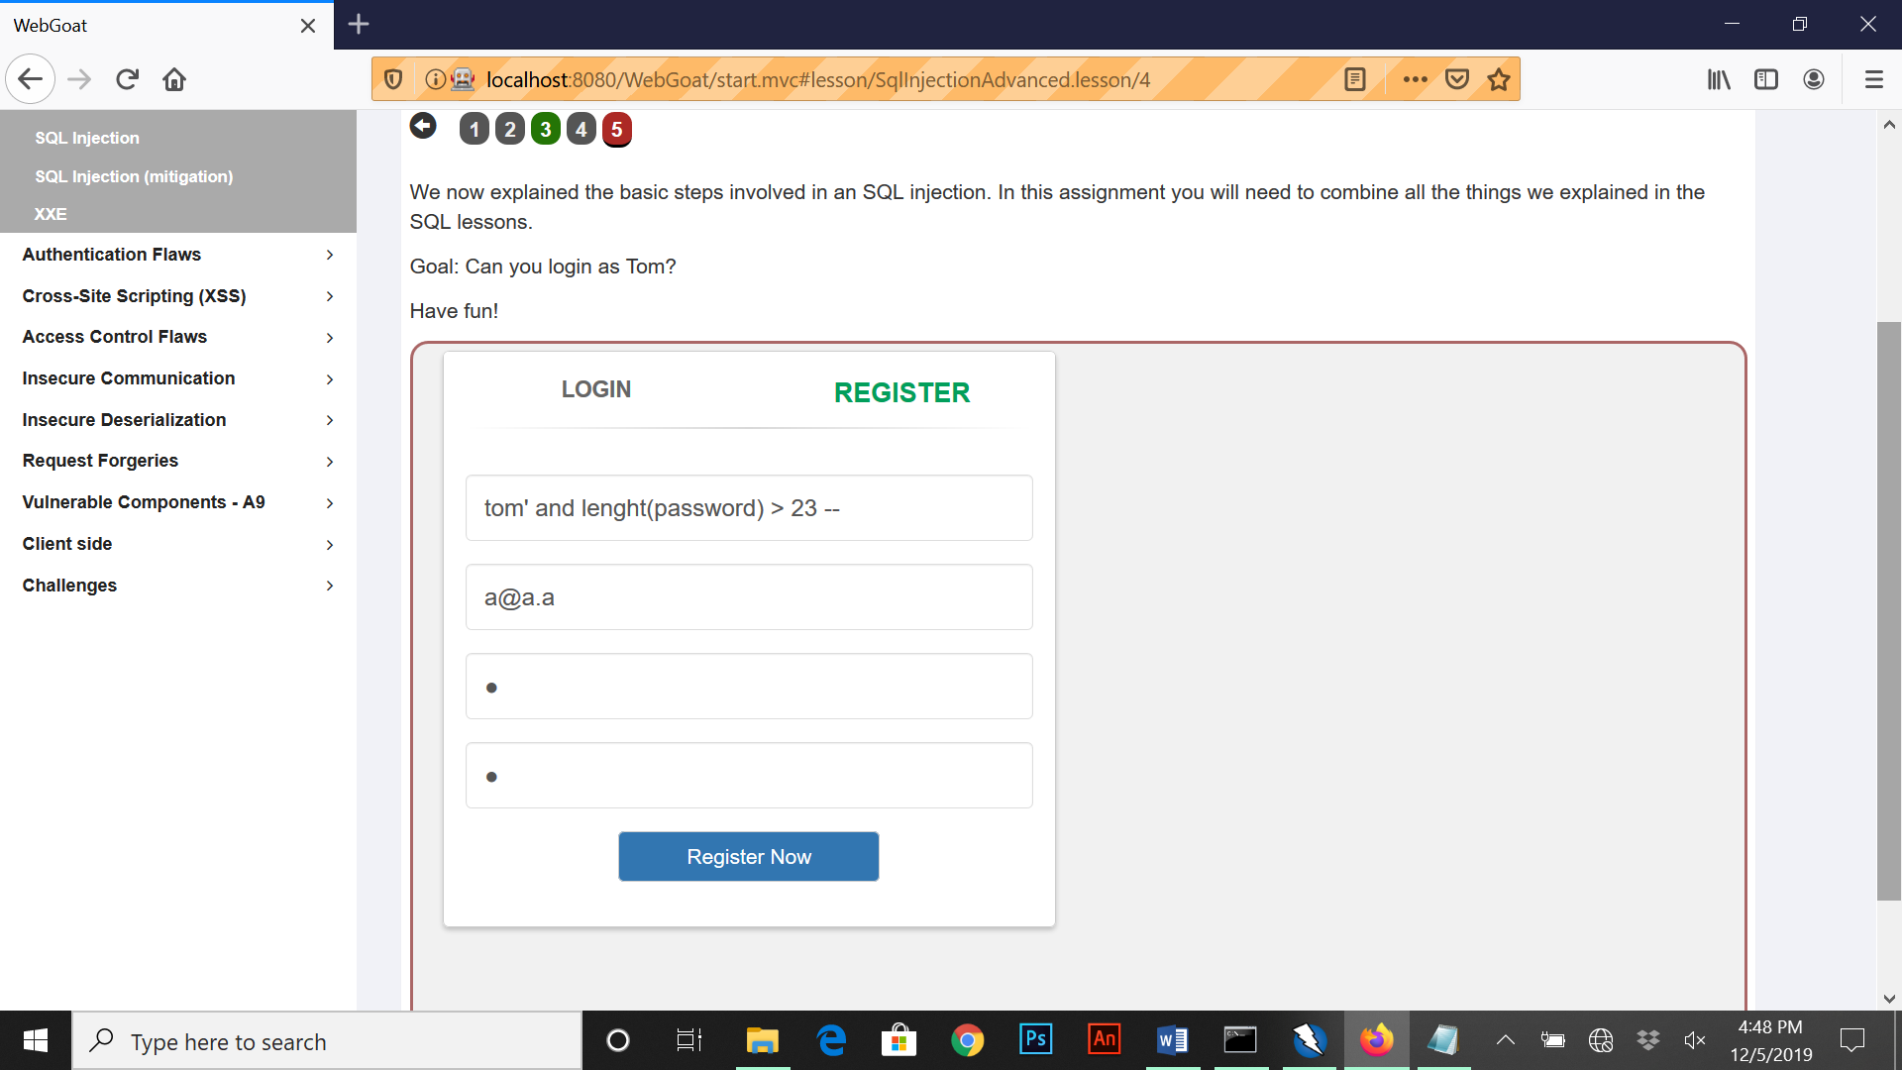

The next step I took was to allocate which letter represented each character of the password using a substring method as follows “tom’ and substring (password1, 1) =’a’ – “. This required a few attempts to get each corresponding letter but soon correct the correct formation of letters for the password.

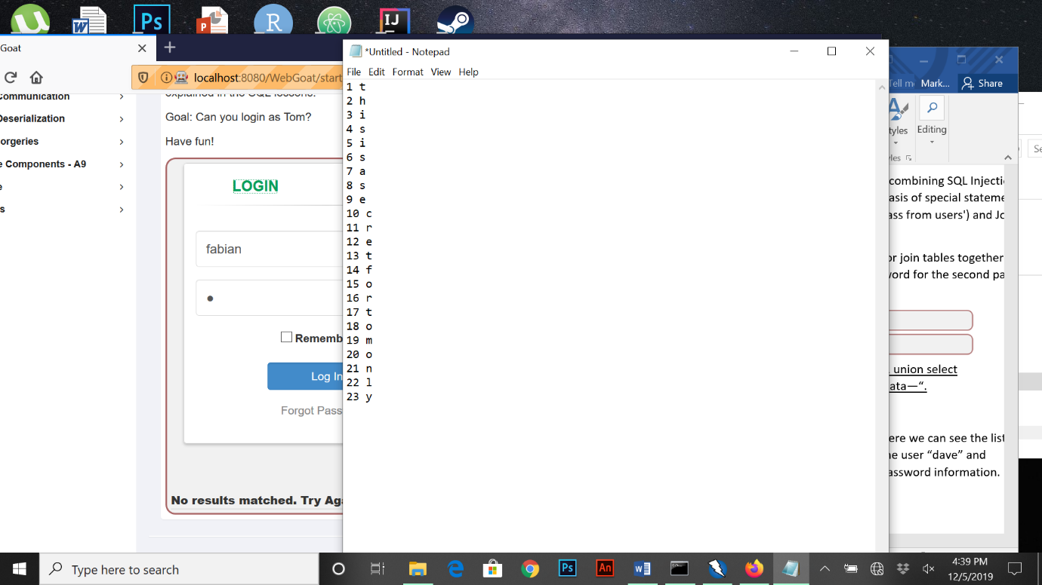From this we went back to the login screen to see if it’s correct.

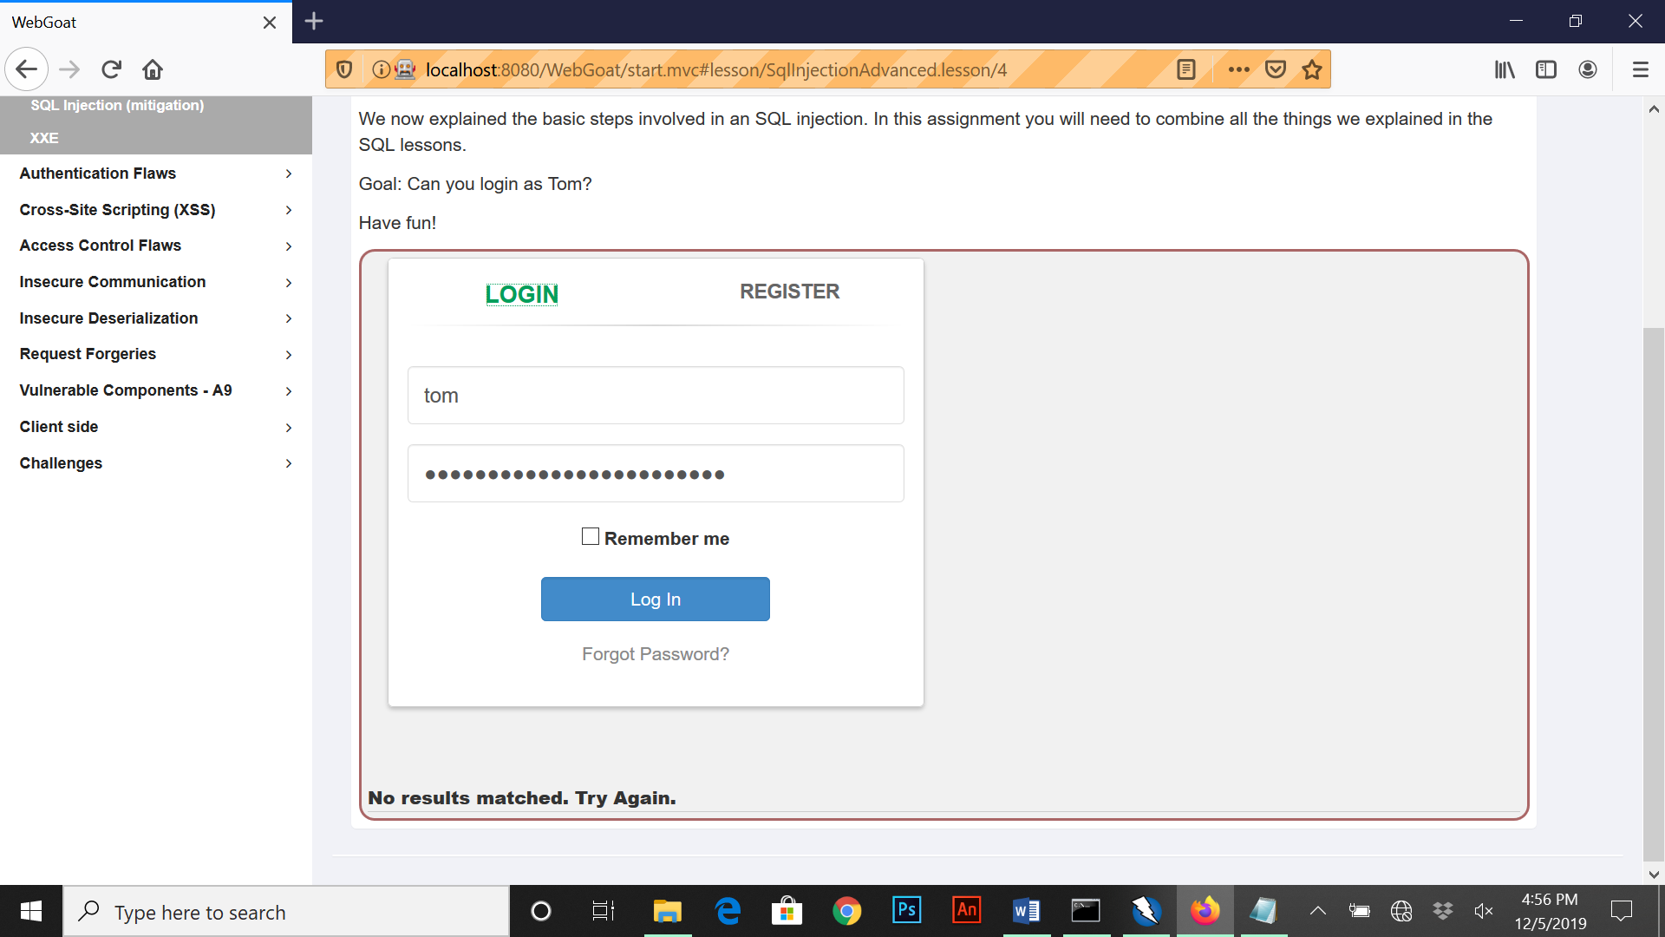

**HTTP Basics**

This lesson covers the basics of understanding transfer of data between browser and the web application being used and to trap a request/response with a HTTP proxy. The goal of this lesson is to use the features of Web Goat by manipulating by manipulating buttons to show HTTP request parameters, HTTP request cookies, and Java source code.

The first part of the lesson asks to enter our name and press Go to send a request to the server and a response back to us.

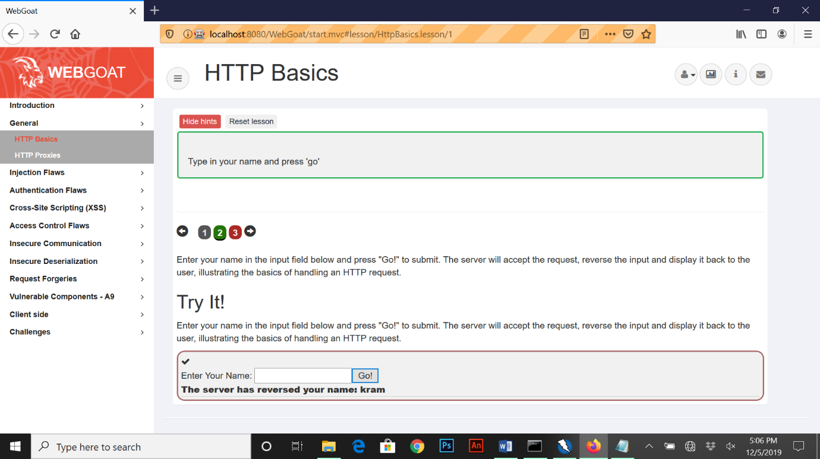

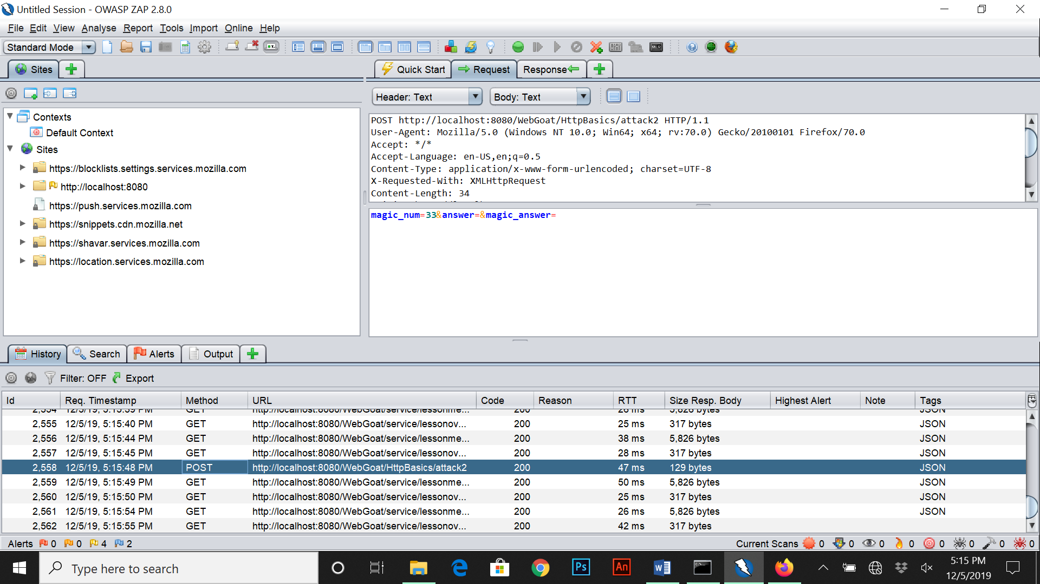For the second part of the lesson we are expected to find a magic number when submitting a post from Web Goat and intercepting it on Zap. When I hit submit with nothing inputted the data shows on the history on Zap as a post with the magic number.

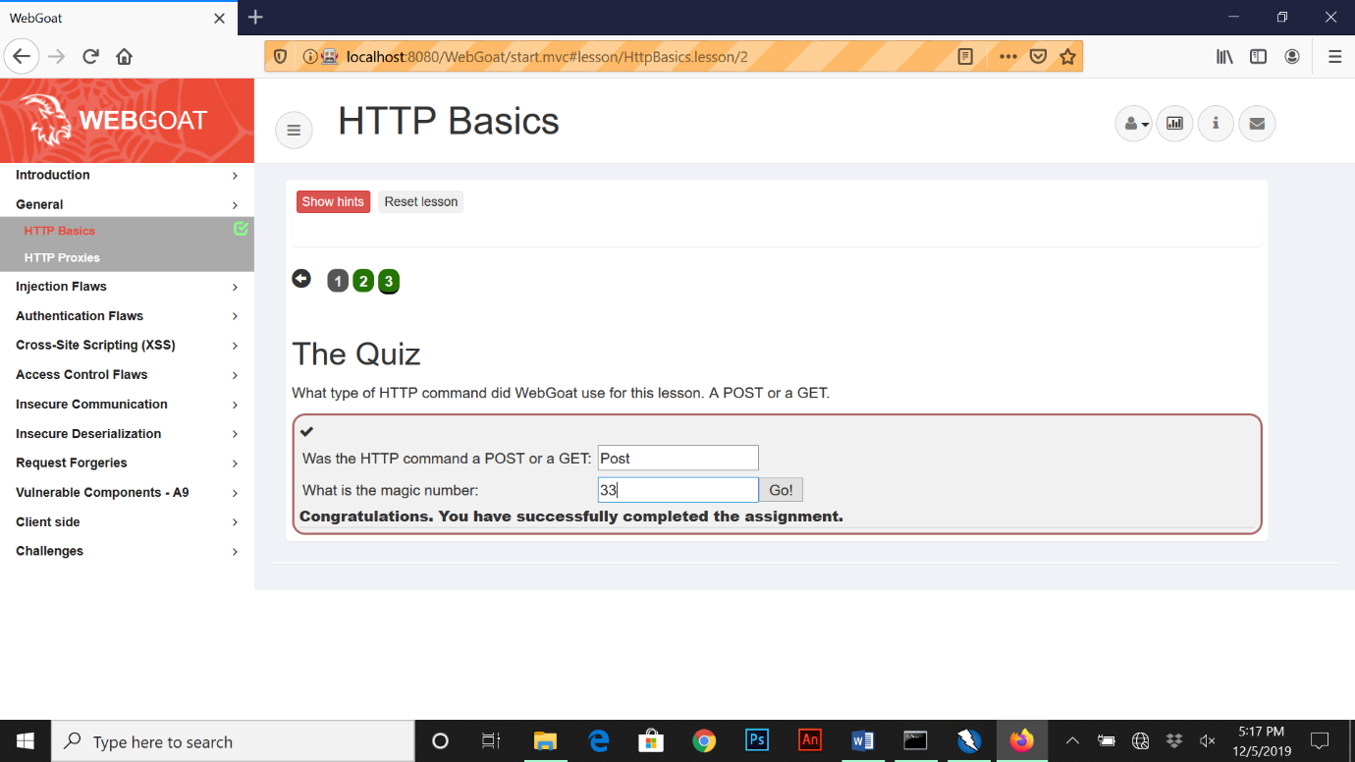

**HTTP Proxies**

For this exercise were first asked to configure our Zap application’s proxy settings to port 8090 with localhost. From there we have to also configure the proxy configuration settings for Firefox as follows (Advanced, Network, Settings, Manual proxy configuration). Here we input **a.** 127.0.0.1 as the proxy **b.** 8090 as the port number and **c.** checkbox for using proxy on all protocols.

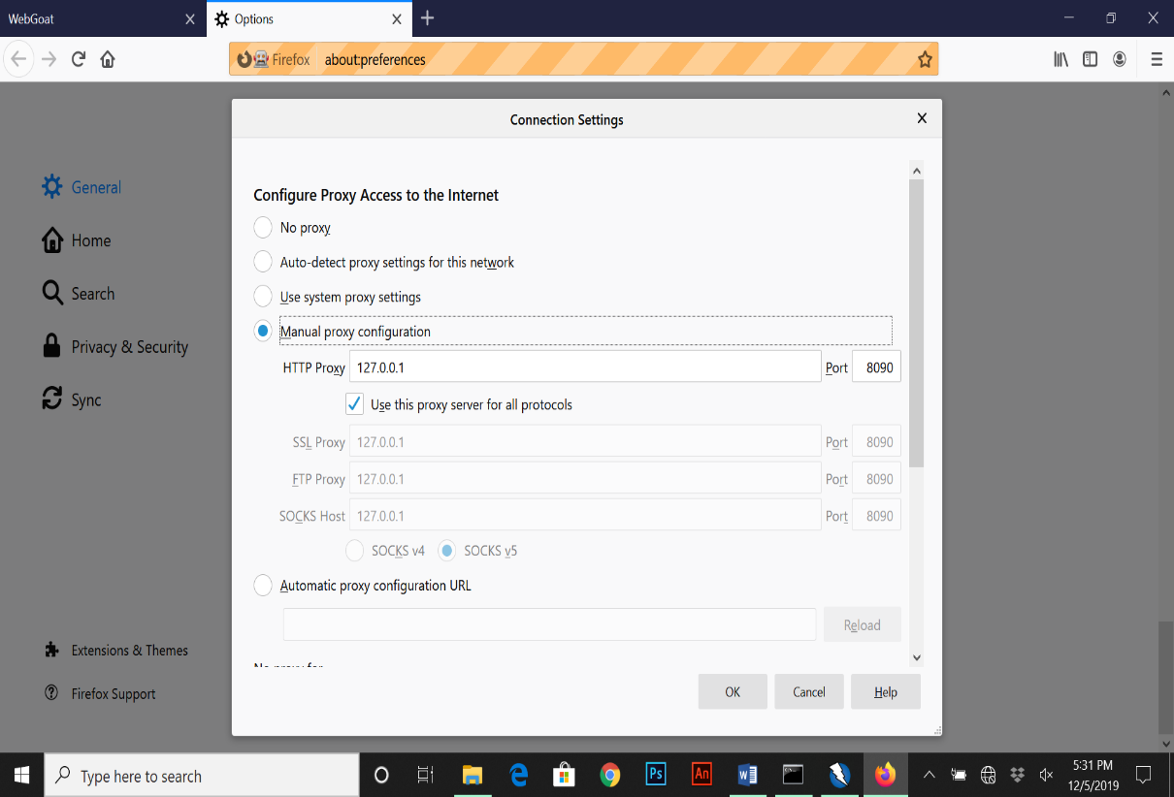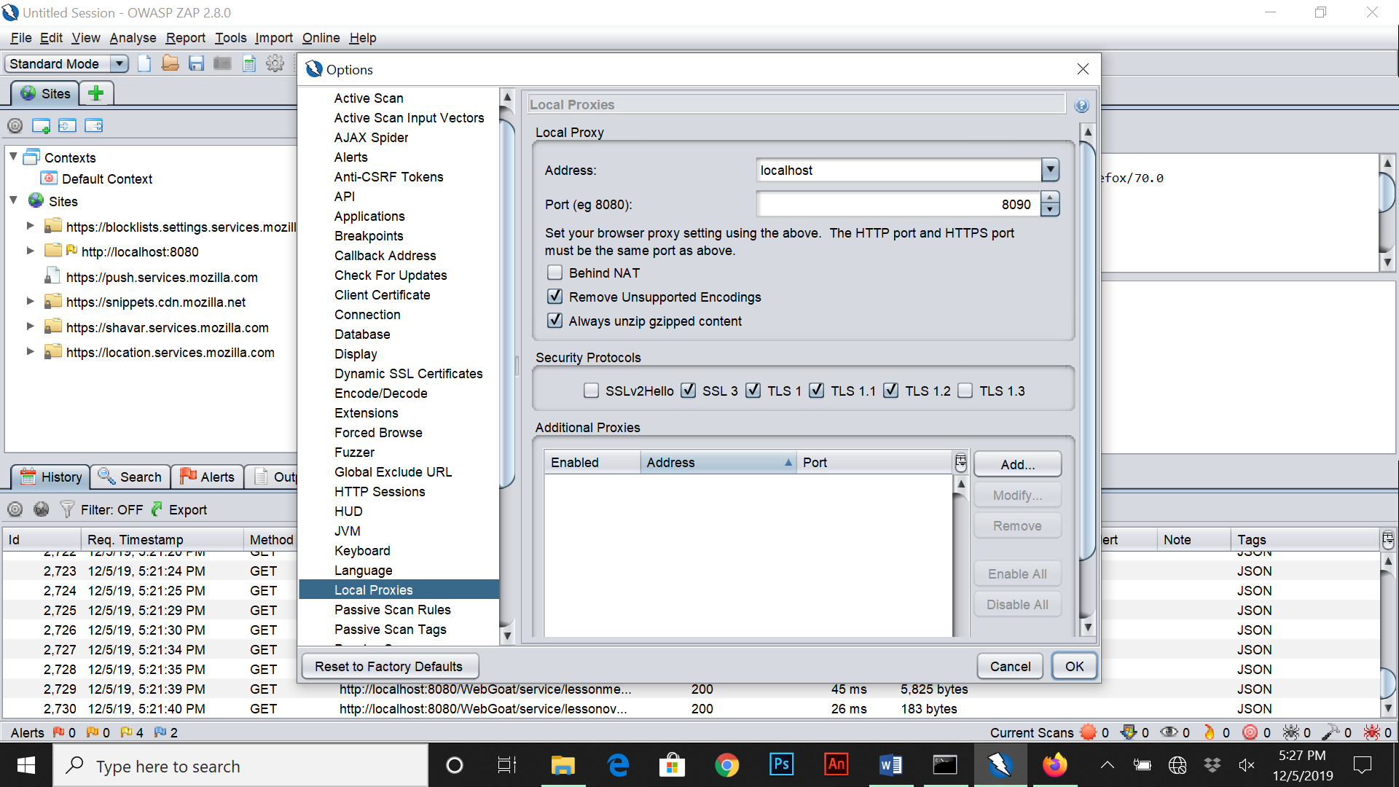

Once we’ve made the nessessary changes we are then asked to intercept a request by hitting the record button on Zap after submitting the request at the buttom of the lesson. From here I press play and the code shows under the break heading below.

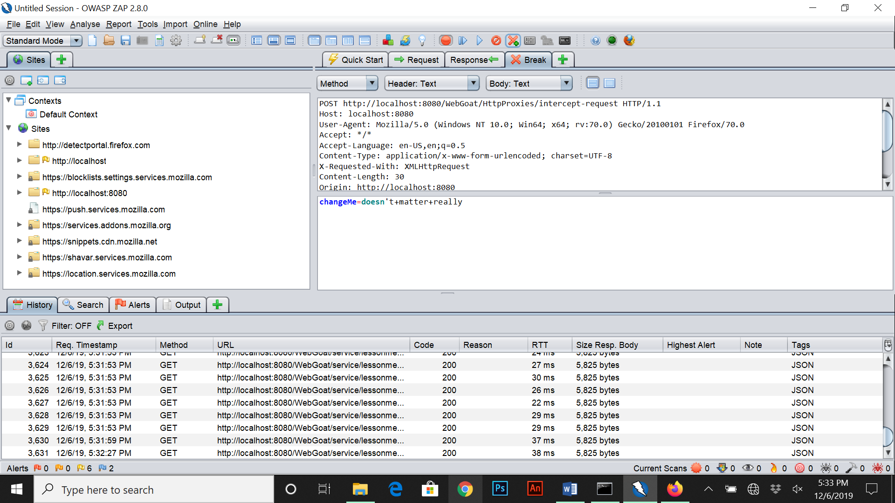

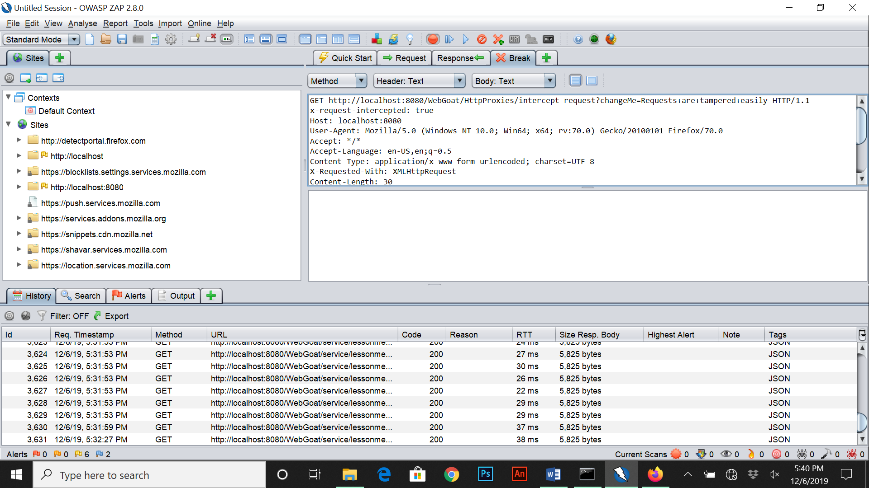The next steps to take were to change the method to “Get” above break, add a header to the code called “x-requested-intercepted: true” and change the input value to “Request+are+tampered+easily”. From there I pressed the play button and the request came back tampered as expected.

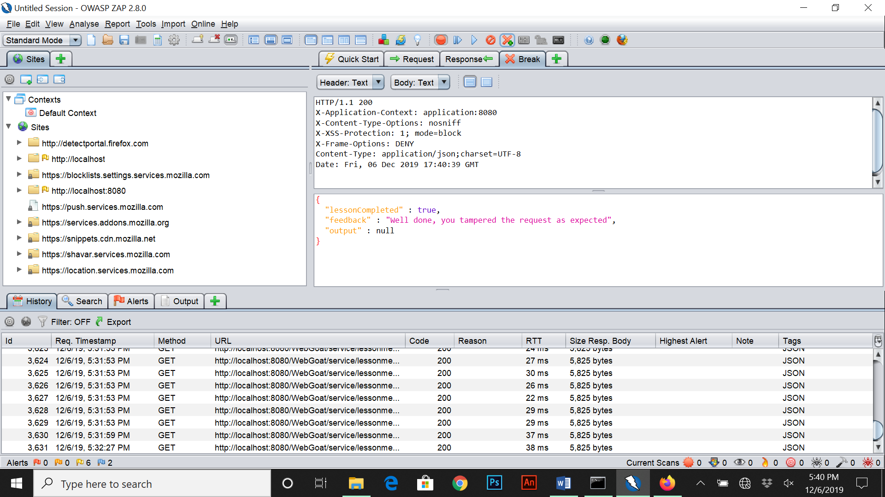

**Authentication Bypass – 2FA Password Reset**

For this exercise we’re given a scenario of a secondary security question page with a provided username/email and are opting for the secondary security method. Like mentioned in a previous method, a proxy has to be setup. The first step I took was going to Zap and pressing the intercept button and filling in the security questions information with wrong info.

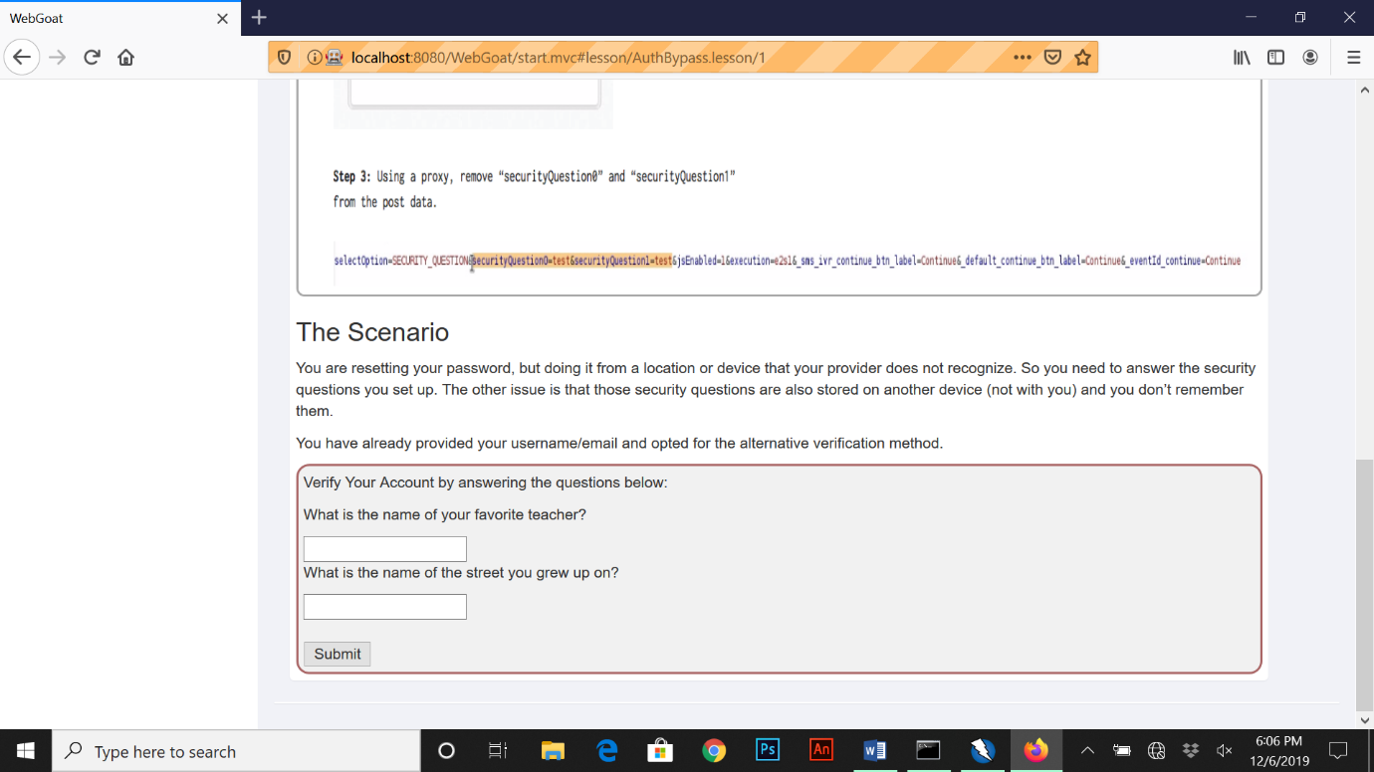

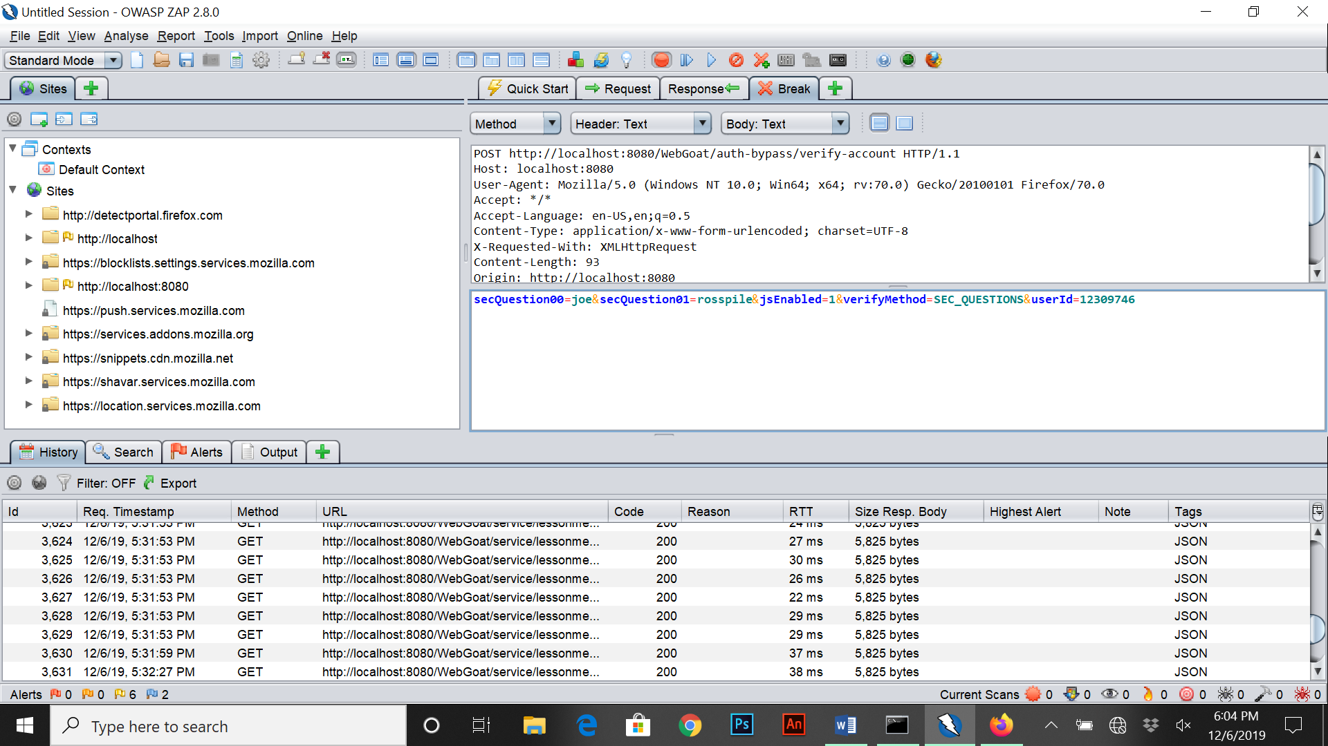Once I clicked submit, in Zap I had to press play and select the get method to show security question request information. From here I simply added a “0” to security question 0 and 1 and pressed play.

Once sent back with the following changes, the form was completed with the following input boxes to change password.

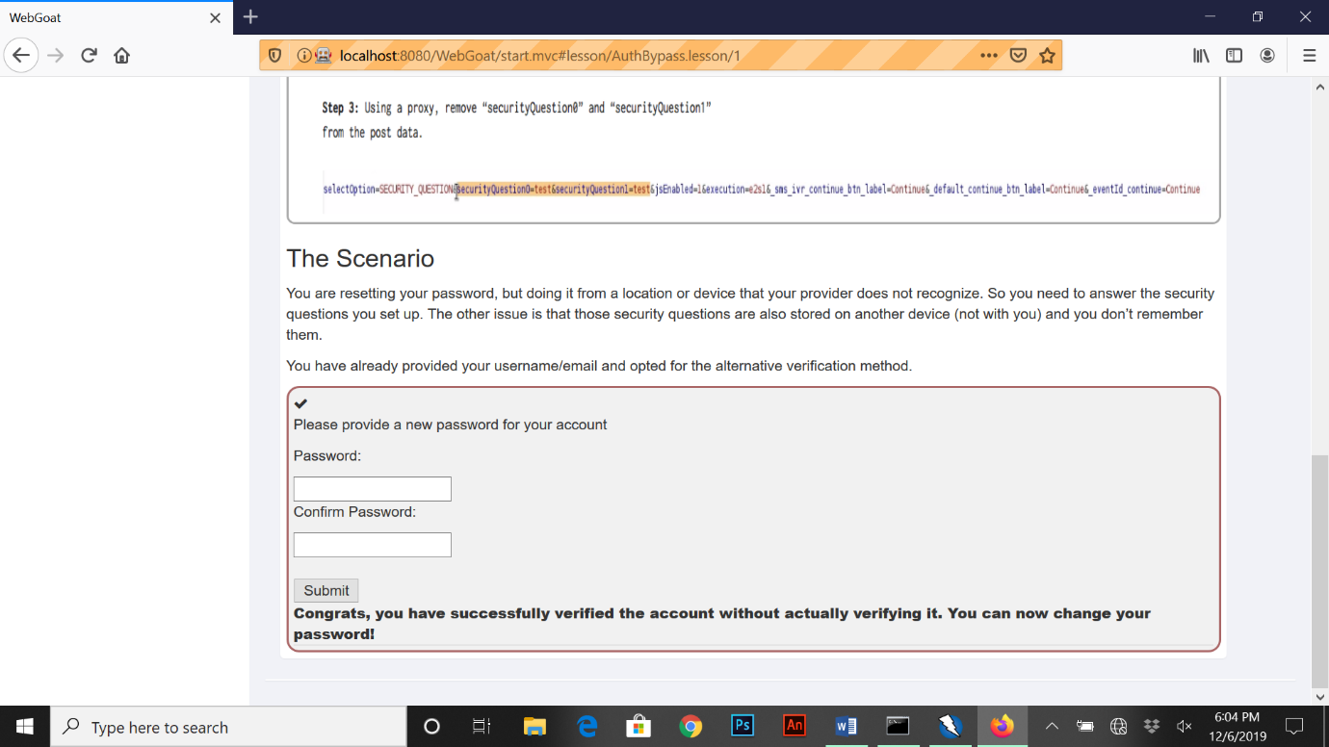

**Client Side Filtering**

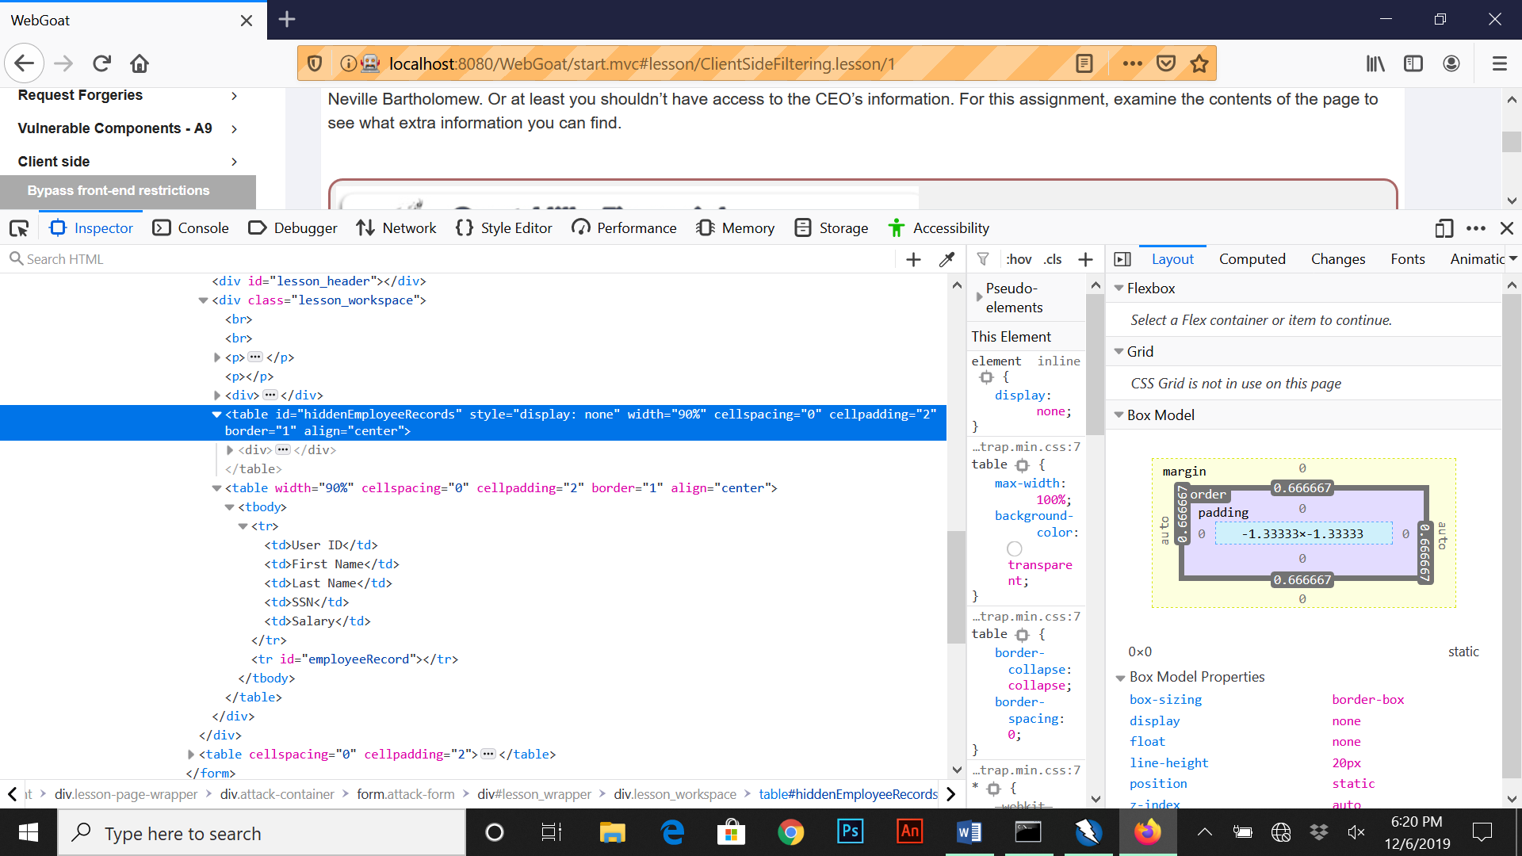This topic focuses on revealing information being returned from a server that we should not be seeing. For the first section we are given a database of employees with their individual information via a drop down menu. The goal here is to find out “Neville Bartholomew” total salary. For this we first need to hover over first name on the table and right click inspect element.

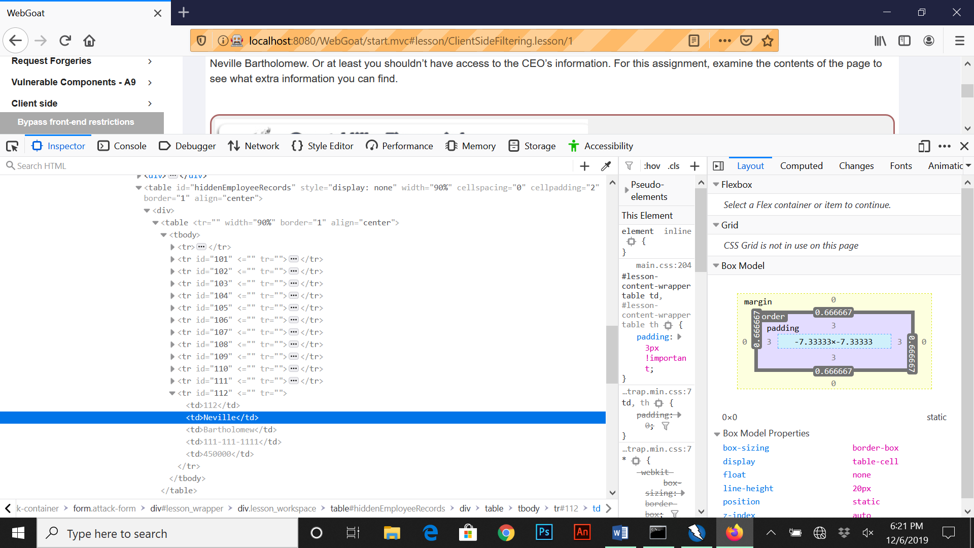When we inspect element over the following section, we see a section labelled table id with “hidden employee records”. Once I clicked onto this and the respected sub folders and div files beneath it we see a total of 12 users this time. Under the 12th user we see Neville’s information with a total salary of 450,000.

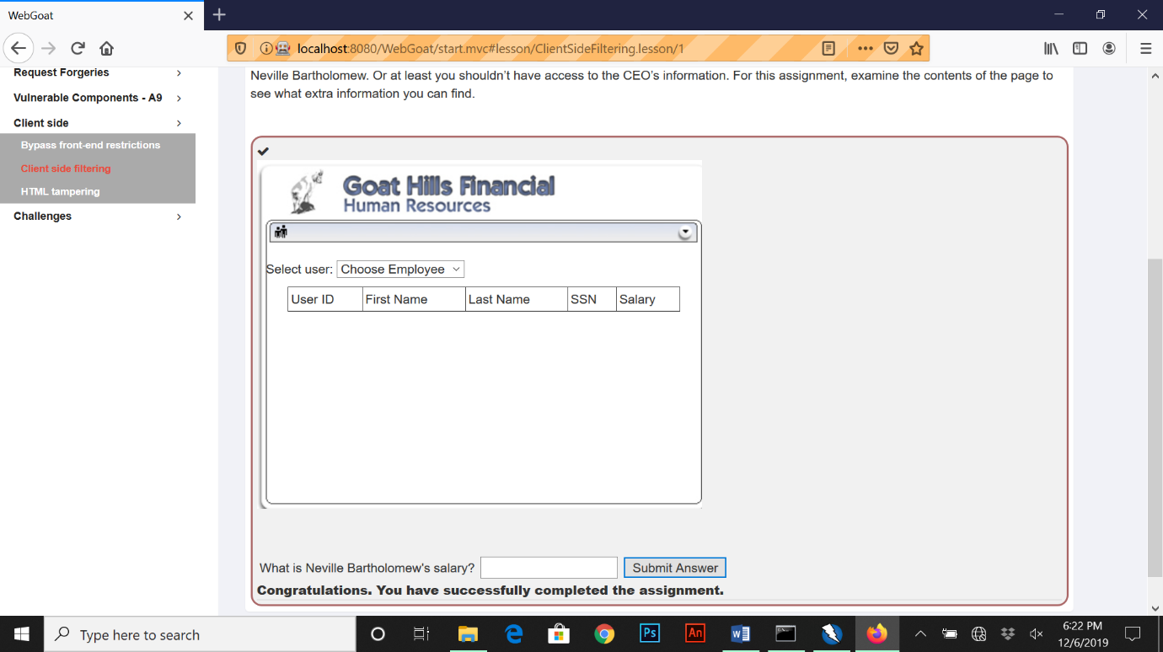

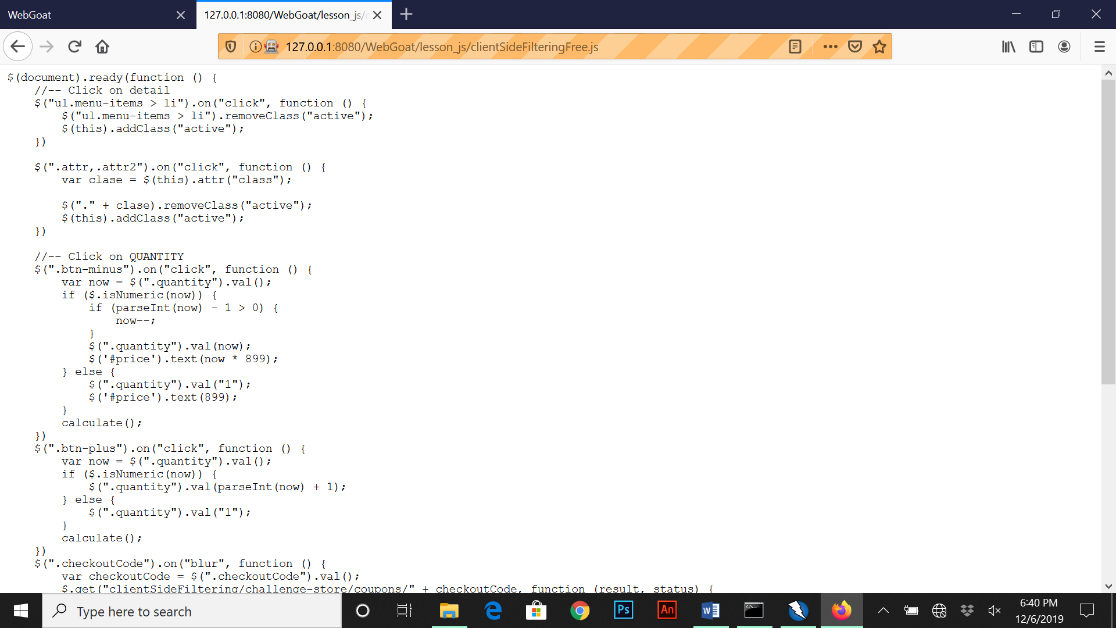For the next section of this exercise we are presented with a buy product page for a mobile phone and are expected to find the code. The first thing I did was right click inspect element over “checkout code” and found a JavaScript file called “clientsidefilteringFree.js”. I then copied this file and opened a new tab on the browser, then entered the following “127.0.0.1:8080/WebGoat/lesson_js/clientSideFilteringFree.js”.

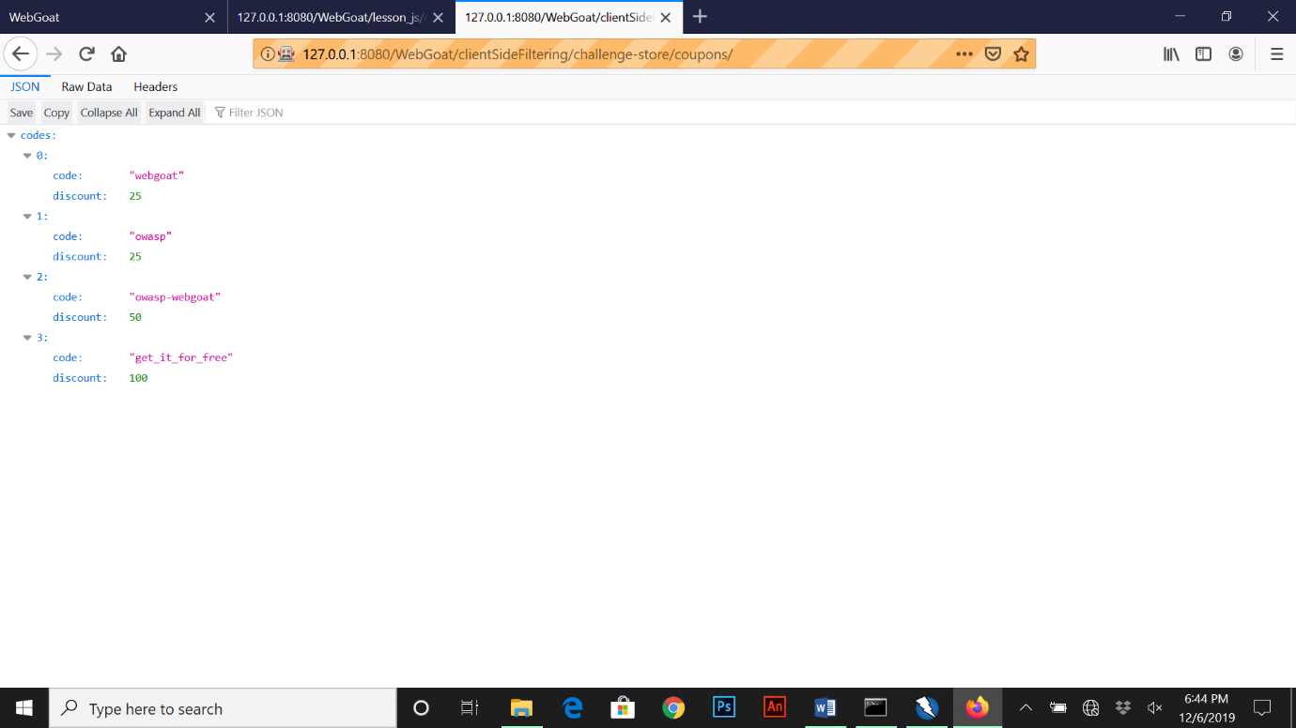This is the js page when copied to a new tab, on this script contains another page called “clientSideFiltering/challenge-store/coupons/” to which we copy and paste the following onto a new tab “127.0.0.1:8080/clientSideFiltering/challenge-store/coupons/” and gives us the generated codes below.

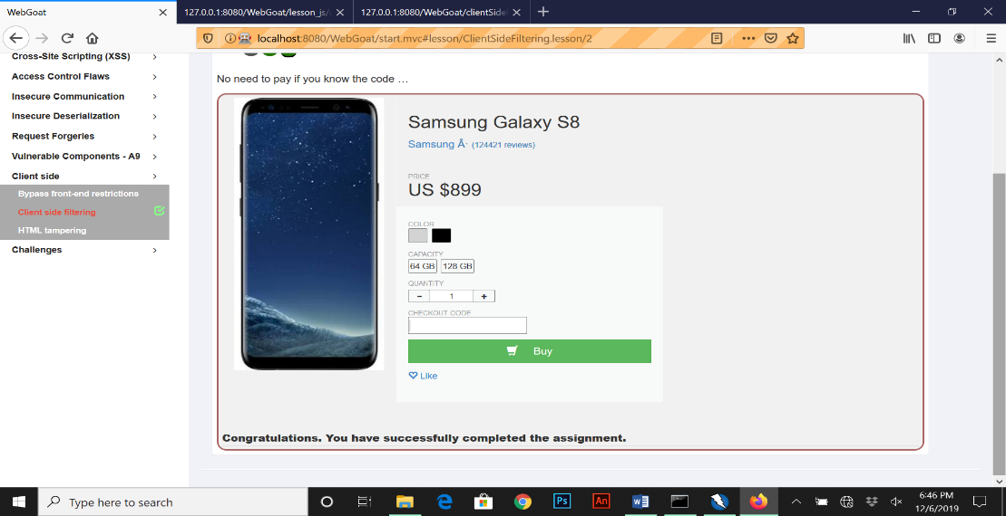From this we can see the free code called “get_it_for_free” from the server. From here we go back to the original phone buying page and enter the code and that’s it.

**Insecure Login**

For this exercise we are expected to intercept a login request from the WebGoat server using Zap. The first step I had to take was to enable the intercept (red button) on Zap and press login on the web page.

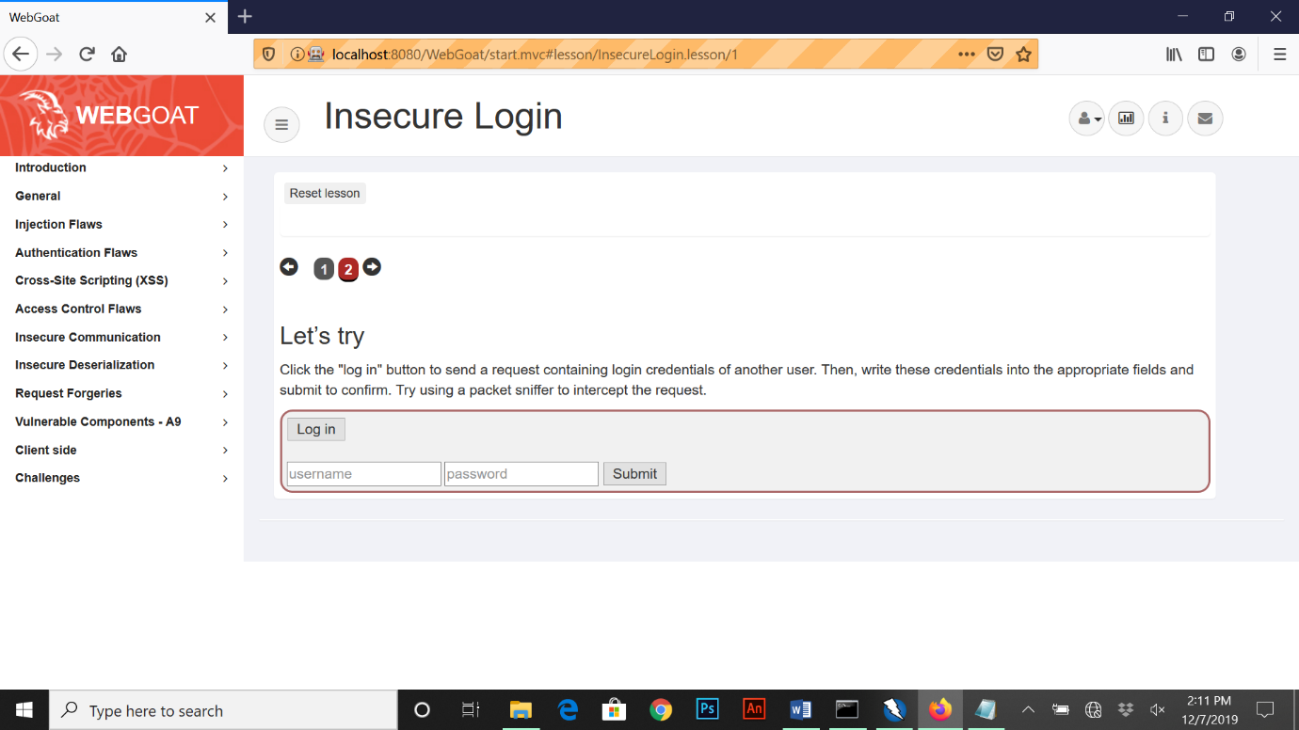

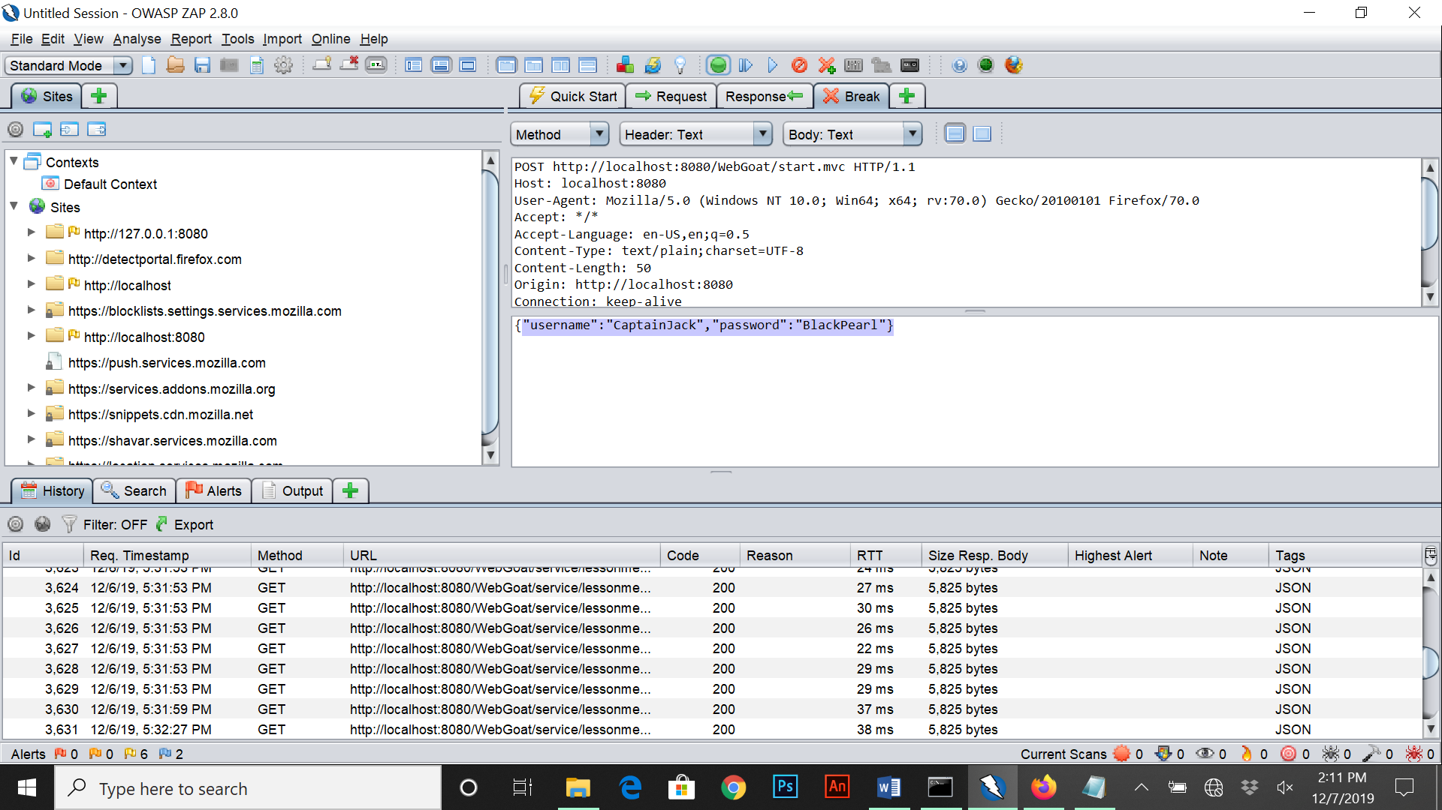Once the login button was pressed, a request was submitted and intercepted on Zap with get method switched on. From there we are able to see the requested username and password (CaptainJack, Blackpearl1).

Once we had the username and password, we go back to the web goat page and enter the credentials which were successful.

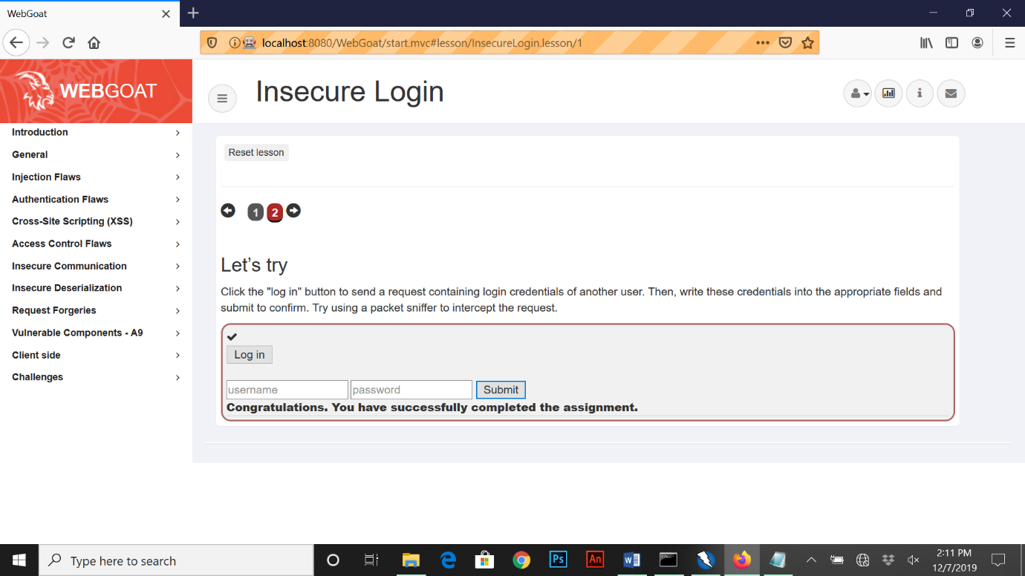

**HTML Tampering**

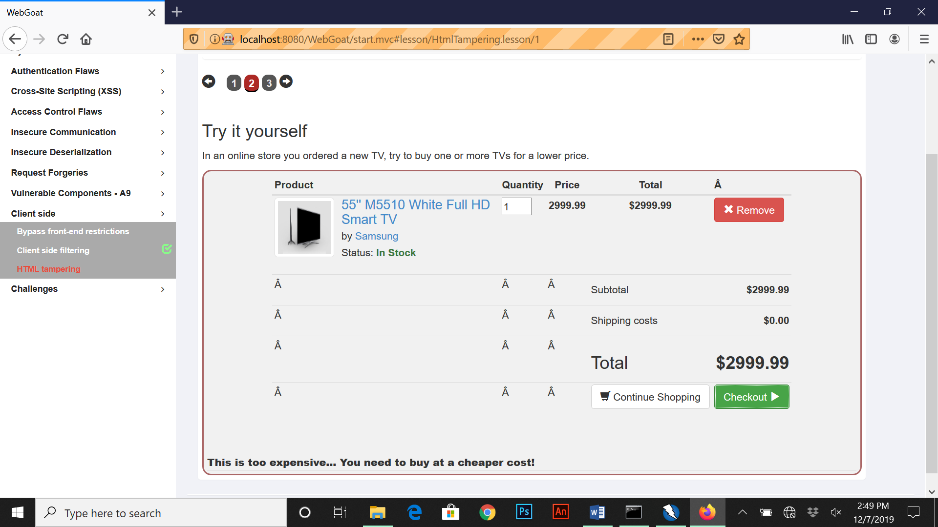For this exercise we have a client side html page that shows a television selling for 2999.99 and our task is to discount the cost. In Zap I enabled the intercept button and pressed the checkout button on the html page.

In Zap once I can see the initial cost sent as a request and can adjust it to send back, for example I edited the price to be 0.99 instead and pressed play.

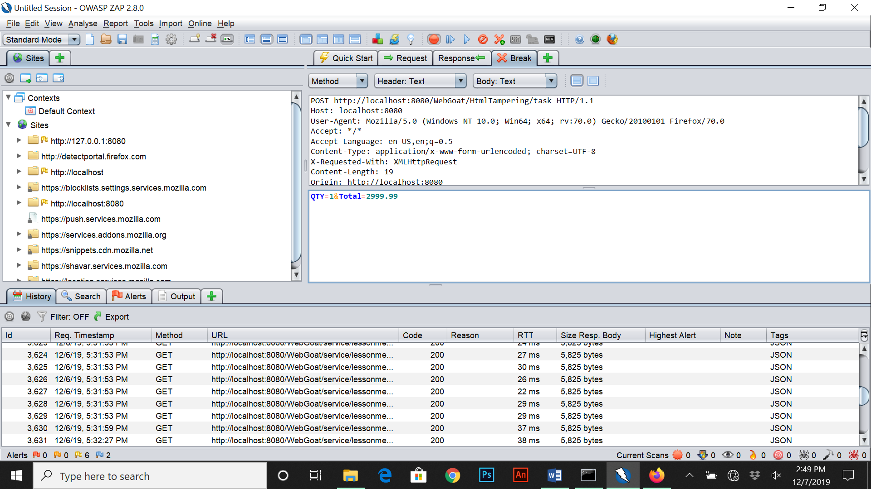

When we revisit the web goat html page we can now see a congratulations message on editing the initial price on Zap and sending back the request from the server.

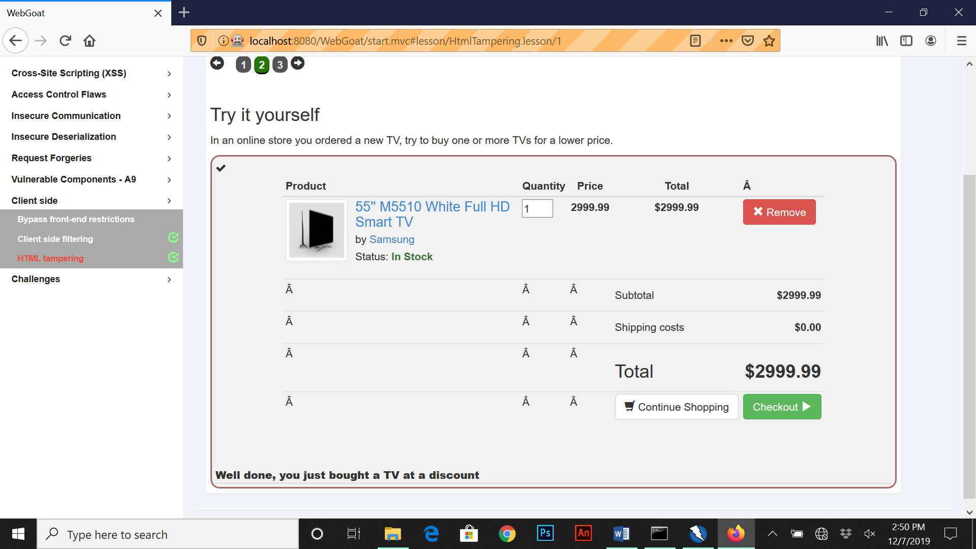

**Learning Outcomes from Each Task**

**SQL Injection (Normal)**

Having a better understanding of string injection and numeric injection and being able to practically put that to use on different input boxes for different responses.

**Missing function Level Access Control**

Being able to inspect elements on different HTML web pages for hidden files or weaknesses and be able to locate and find script files using Zap.

**SQL Injection (Advanced)**

Learning new variations of SQL injection techniques and the use of blind SQL Injection on forms and logins. Also being able to understand the use of substring methods when using SQL Injection.

**HTTP Basics**

Being able to understand the transfer of data between browser and the web application being used and to trap a request/response with a HTTP proxy

**HTTP Proxies**

Understanding how to configure proxy settings both on a web browser and Zap. Being able to intercept a request, edit and send back information.

**Authentication Bypasses**

Being able to intercept, modify and send back information using Zap and a setup proxy service to relay back false information.

**Client Side Filtering**

The use of inspect element by finding hidden files and private information on a HTML page. Being able to edit, find and execute different JavaScript files within a web server to find out information.

**Insecure Login**

Intercepting a login request using Zap to find private information not seen on a HTML browser page and using that information to login.

**HTML Tampering**

Be able to intercept a request when using a HTML page to purchase something and edit the information coming back using Zap.